**Follow me on**  
*Medium : https://medium.com/@sonish.sivarajkumar  
Kaggle : https://www.kaggle.com/sonish2383  
GitHub : https://github.com/Sonish2383*

***Top Courses in machine learning, Deep Learning and Data Science for free.***

***If you are curious enough to learn by your own.***

***Here is something for you to learn and deploy your skills.***

***Sonish S***

**Courses with certificates**

**Amazon AWS**

[**https://www.aws.training/Dashboard**](https://www.aws.training/Dashboard)

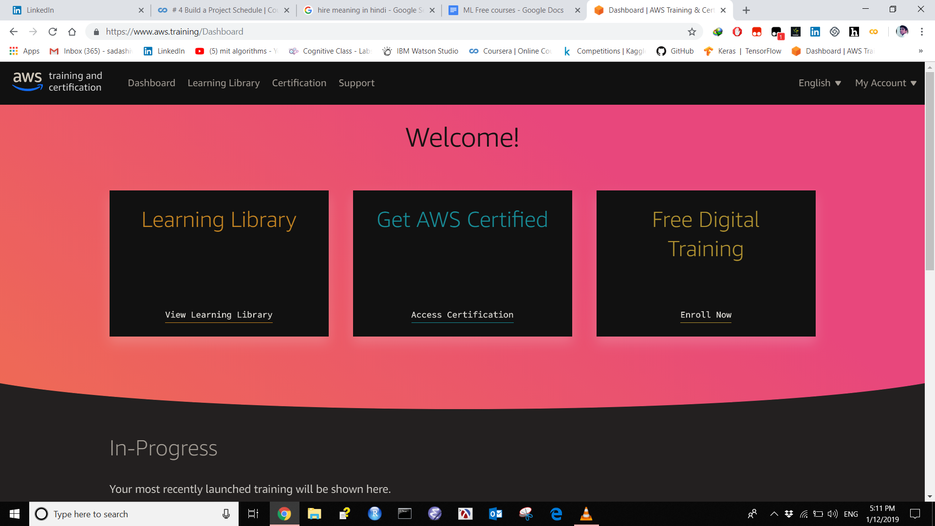

**IBM Watson studio**

**Cognitive class**

[**https://cognitiveclass.ai/**](https://cognitiveclass.ai/)

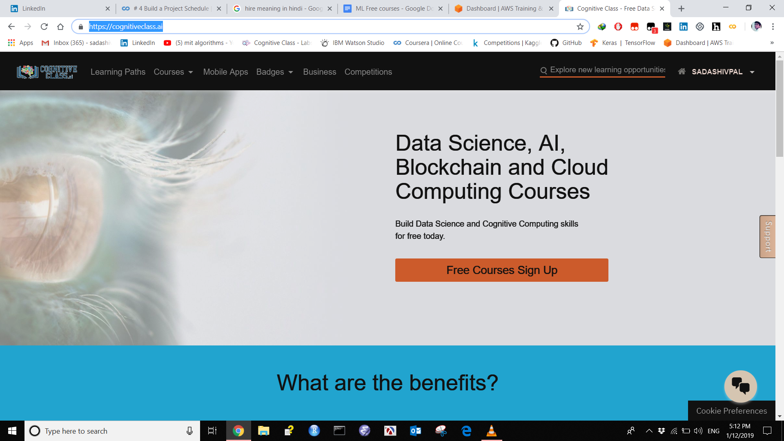

Courses without certificates

1 **[Machine Learning](https://courses.cs.washington.edu/courses/cse546/17au/)**

University of Washington

This course is designed to provide a thorough grounding in the fundamental methodologies and algorithms of machine learning. The topics of the course draw from classical statistics, from machine learning, from data mining, from Bayesian statistics, and from optimization.

Prerequisites: Students entering the class should be comfortable with programming and should have a pre-existing working knowledge of linear algebra, probability, statistics and algorithms.

<https://courses.cs.washington.edu/courses/cse546/17au/>

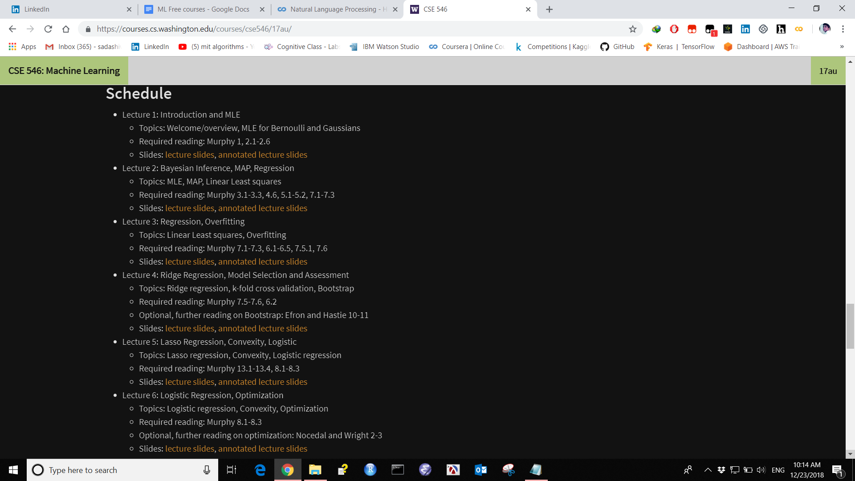

**200 Best Resources**

[https://medium.com/machine-learning-in-practice/over-200-of-the-best-machine-learning-nlp-and-python-tutorials-2018-edition-dd8cf53cb](https://medium.com/machine-learning-in-practice/over-200-of-the-best-machine-learning-nlp-and-python-tutorials-2018-edition-dd8cf53cb7dc)

**2.** [**Machine Learning**](http://pages.stat.wisc.edu/~sraschka/teaching/stat479-fs2018/)

University of Wisconsin–Madison

This course will cover the key concepts of machine learning, including classification, regression analysis, clustering, and dimensionality reduction. Students will learn about the fundamental mathematical concepts underlying machine learning algorithms, but this course will equally focus on the practical use of machine learning algorithms using open source libraries from the Python programming ecosystem.

<http://pages.stat.wisc.edu/~sraschka/teaching/stat479-fs2018/>

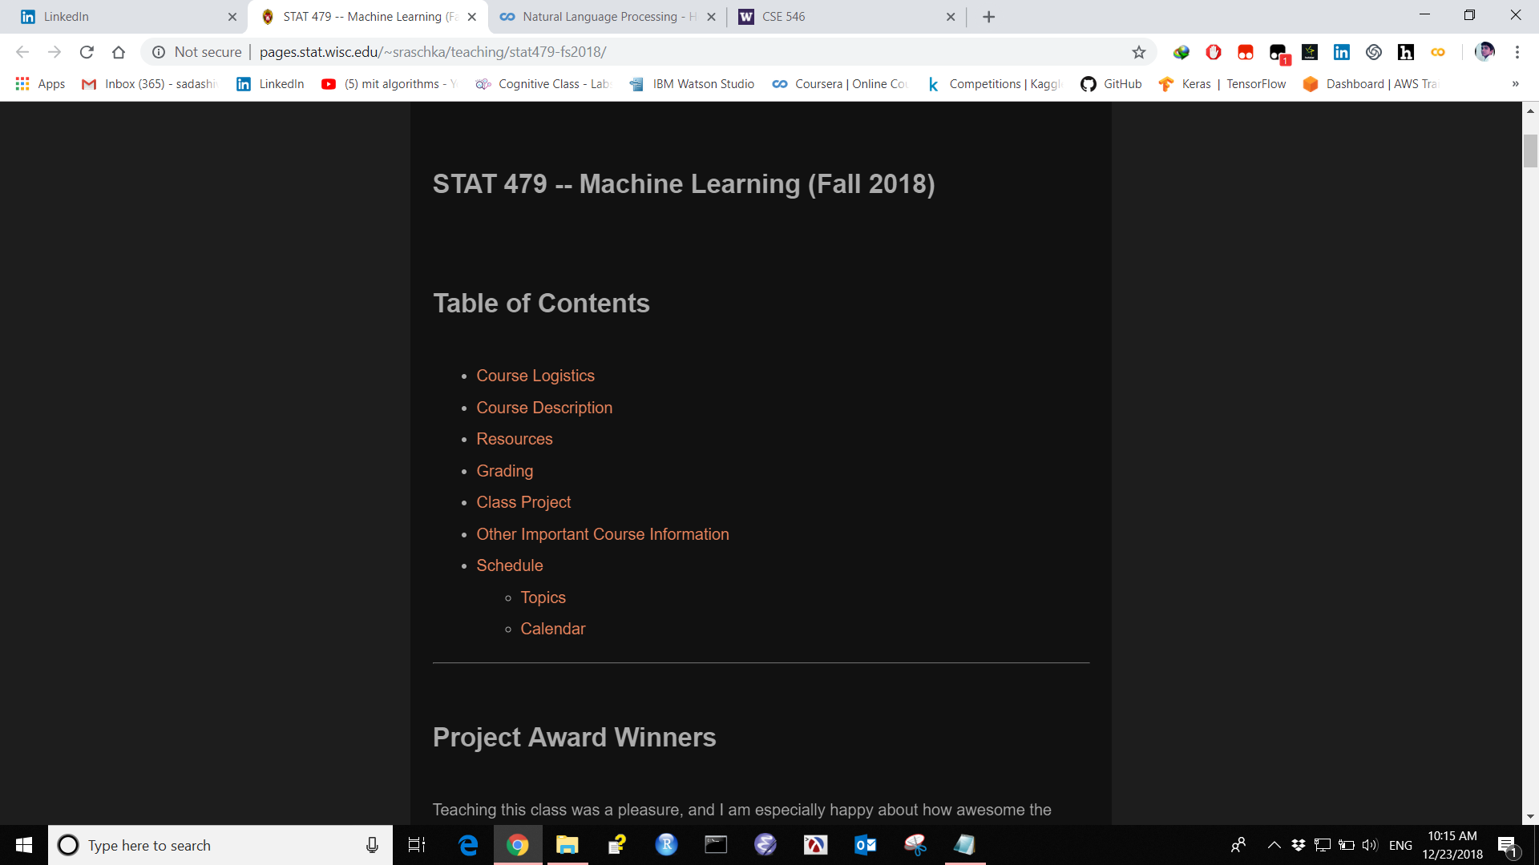

**3. [Algorithms (in Journalism)](https://github.com/jstray/lede-algorithms/blob/master/README.md)**

Columbia University

This is a course on algorithmic data analysis in journalism, and also the journalistic analysis of algorithms used in society. The major topics are text processing, visualization of high dimensional data, regression, machine learning, algorithmic bias and accountability, monte carlo simulation, and election prediction.

All coding is done in Python, using Pandas, matplotlib, scikit learn.

<https://github.com/jstray/lede-algorithms/blob/master/README.md>

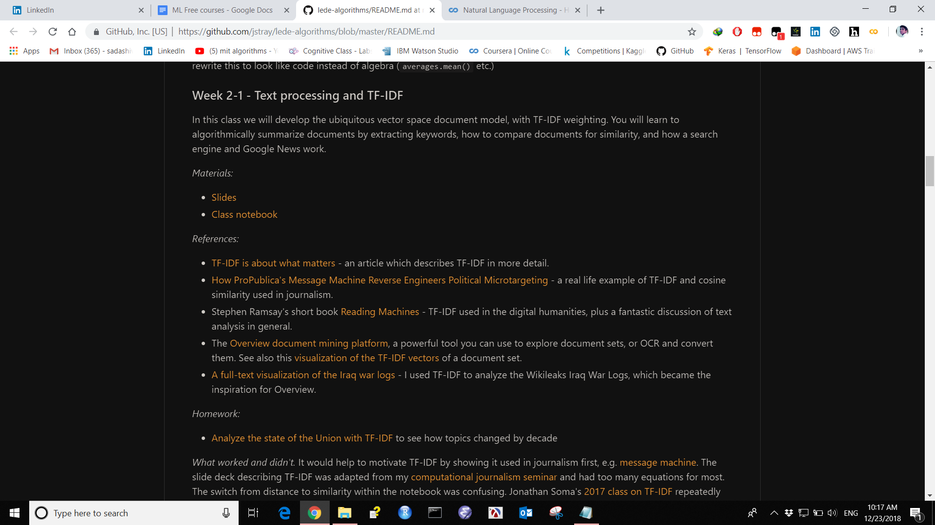

**4.** [**Practical Deep Learning**](https://github.com/yandexdataschool/Practical_DL/tree/master)

Yandex Data School

<https://github.com/yandexdataschool/Practical_DL/tree/master>

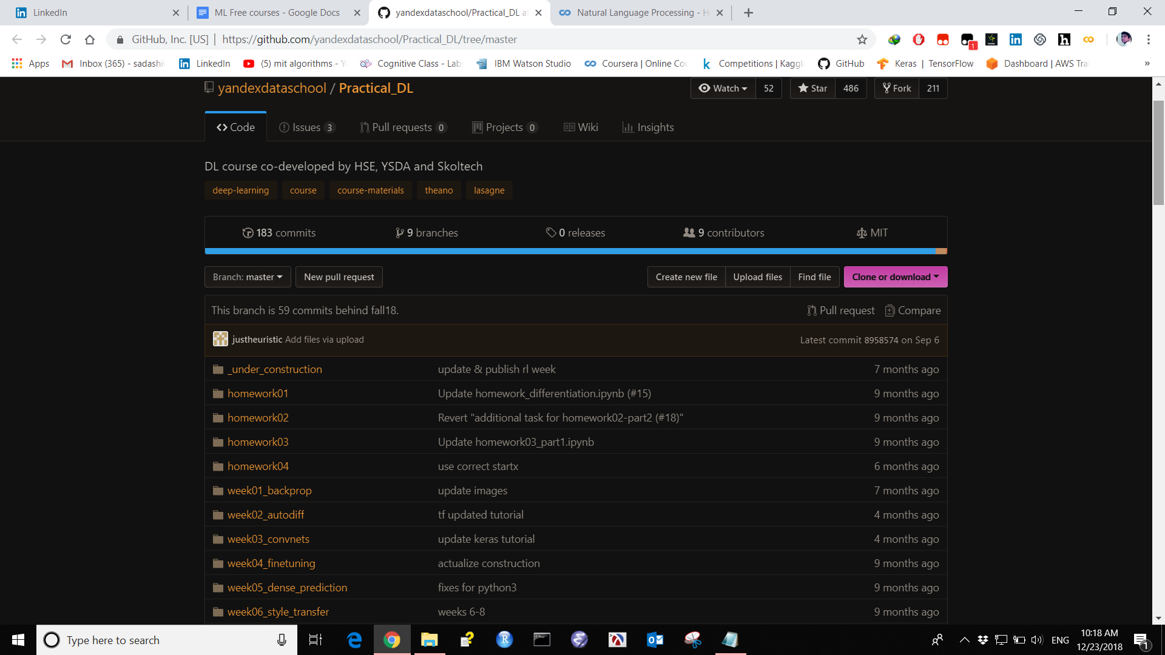

**5. [Big Data in 30 Hours](http://ondata.blog/big-data-in-30-hours/)**

Krakow Technical University

The goal of this technical, hands-on class is to introduce practical Data Engineering and Data Science to technical personnel (corporate, academic or students), during 15 lectures (2 hours each). All subjects are introduced by examples that students are expected to immediately play with using either command-line or GUI tools.

Prerequisites: the participants need to be technical, reasonably fluent in general programming and operating systems, with basic exposure to Linux shell, databases, and SQL. Working knowledge of Python will be needed for the lectures 9-15.

*Note that this course is underdevelopment, and not all lessons have been completed.*

<http://ondata.blog/big-data-in-30-hours/>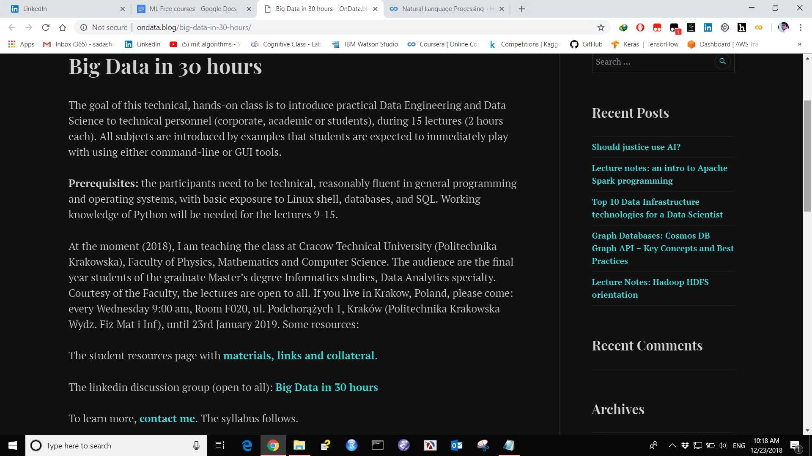

**6. [Deep Reinforcement Learning Bootcamp](https://sites.google.com/view/deep-rl-bootcamp/lectures)**

UC Berkeley (& others)

Reinforcement learning considers the problem of learning to act and is poised to power next generation AI systems, which will need to go beyond input-output pattern recognition (as has sufficed for speech, vision, machine translation) but will have to generate intelligent behavior. Example application domains include robotics, marketing, dialogue, HVAC, optimizing healthcare and supply chains.

​This two-day long bootcamp will teach you the foundations of Deep RL through a mixture of lectures and hands-on lab sessions, so you can go on and build new fascinating applications using these techniques and maybe even push the algorithmic frontier.

<https://sites.google.com/view/deep-rl-bootcamp/lectures>

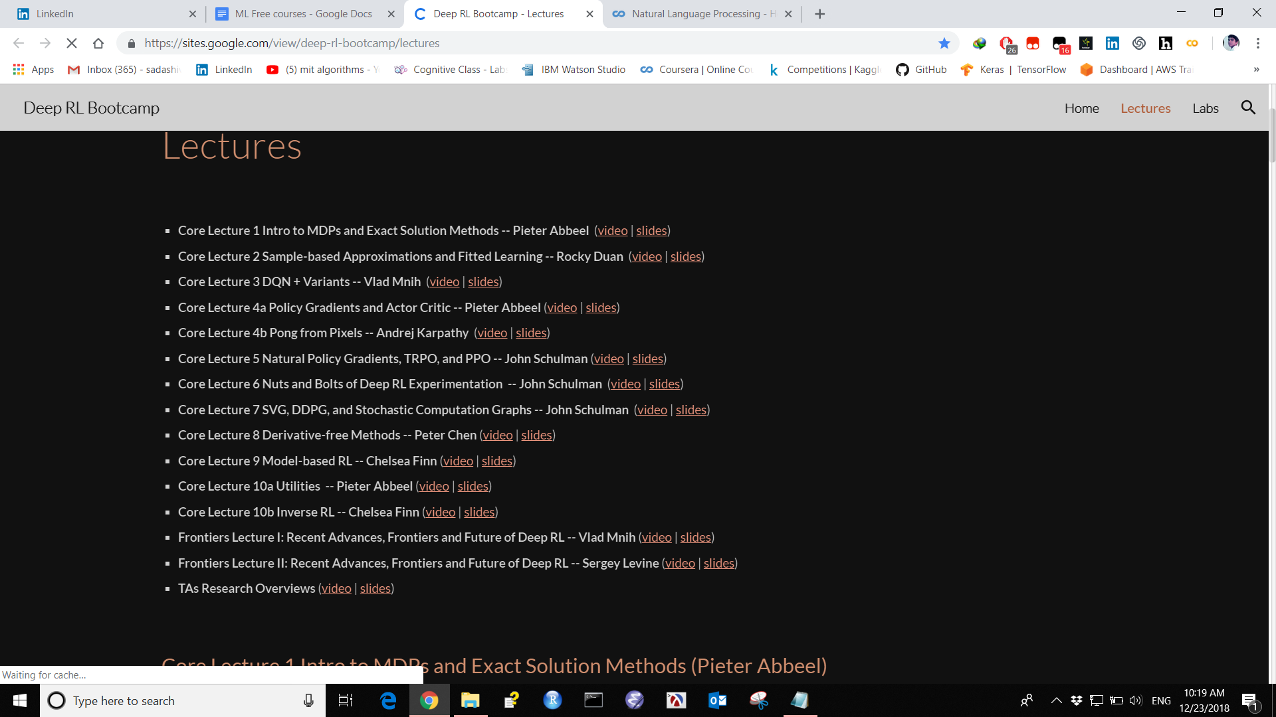

**7. [Introduction to Artificial Intelligence](https://courses.cs.washington.edu/courses/cse573/17wi/)**

University of Washington

Course contain Lectures, Slides.

<https://courses.cs.washington.edu/courses/cse573/17wi/>

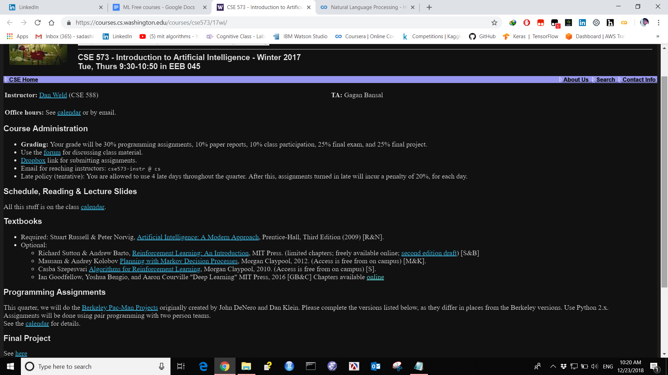

**8. [Brains, Minds and Machines Summer Course](https://ocw.mit.edu/resources/res-9-003-brains-minds-and-machines-summer-course-summer-2015/)**

MIT

This course explores the problem of intelligence—its nature, how it is produced by the brain and how it could be replicated in machines—using an approach that integrates cognitive science, which studies the mind; neuroscience, which studies the brain; and computer science and artificial intelligence, which study the computations needed to develop intelligent machines. Materials are drawn from the Brains, Minds and Machines Summer Course offered annually at the Marine Biological Laboratory

[https://ocw.mit.edu/resources/res-9-003-brains-minds-and-machines-summer-course-su](https://ocw.mit.edu/resources/res-9-003-brains-minds-and-machines-summer-course-summer-2015/)

[mmer-2015/](https://ocw.mit.edu/resources/res-9-003-brains-minds-and-machines-summer-course-summer-2015/)

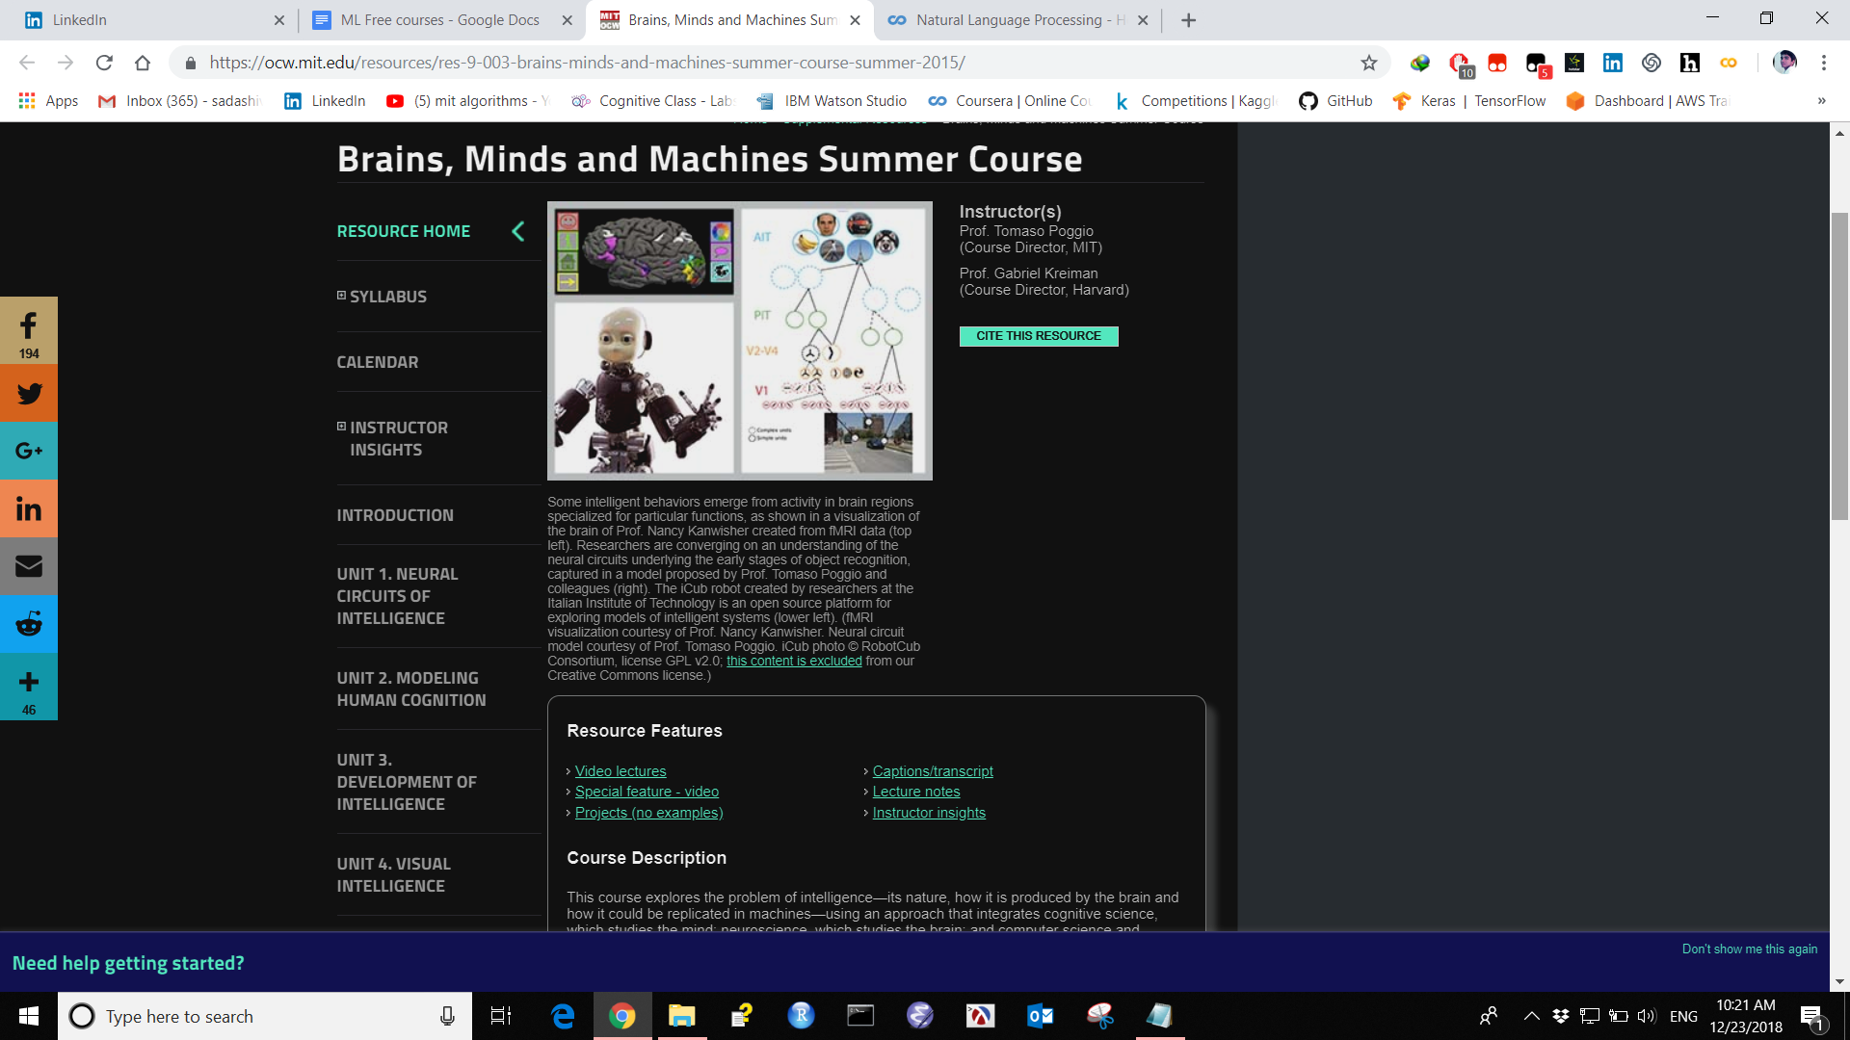

**9. [Design and Analysis of Algorithms](https://ocw.mit.edu/courses/electrical-engineering-and-computer-science/6-046j-design-and-analysis-of-algorithms-spring-2015/)**

MIT

This is an intermediate algorithms course with an emphasis on teaching techniques for the design and analysis of efficient algorithms, emphasizing methods of application. Topics include divide-and-conquer, randomization, dynamic programming, greedy algorithms, incremental improvement, complexity, and cryptography.

<https://ocw.mit.edu/courses/electrical-engineering-and-computer-science/6-046j-design-and-analysis-of-algorithms-spring-2015/>

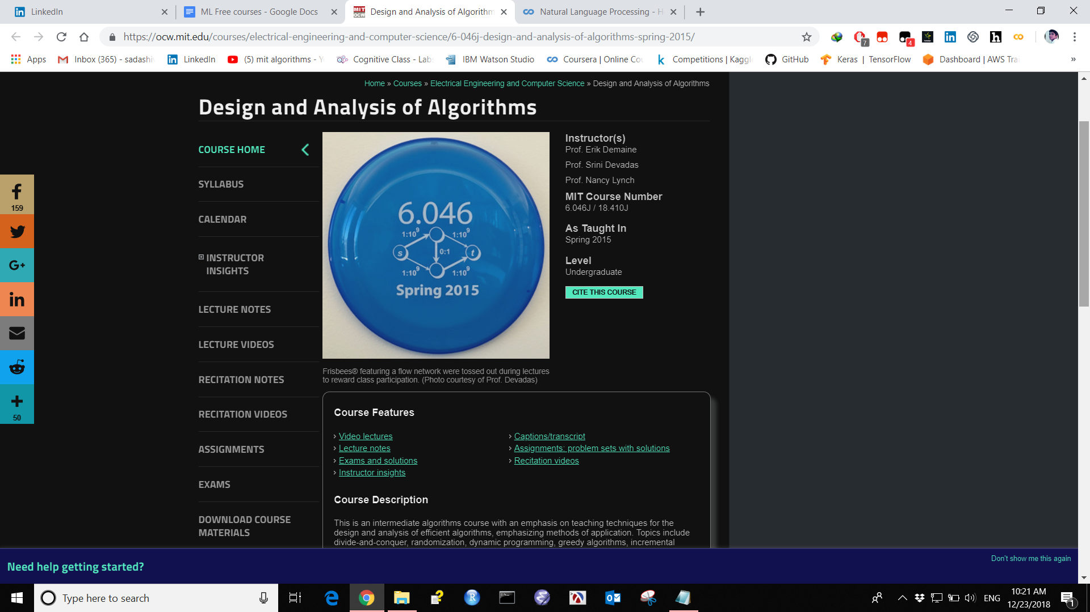

**10. [Natural Language Processing](https://courses.cs.washington.edu/courses/cse517/17wi/)**

University of Washington RNN LSTM GRU

<https://courses.cs.washington.edu/courses/cse517/17wi/>

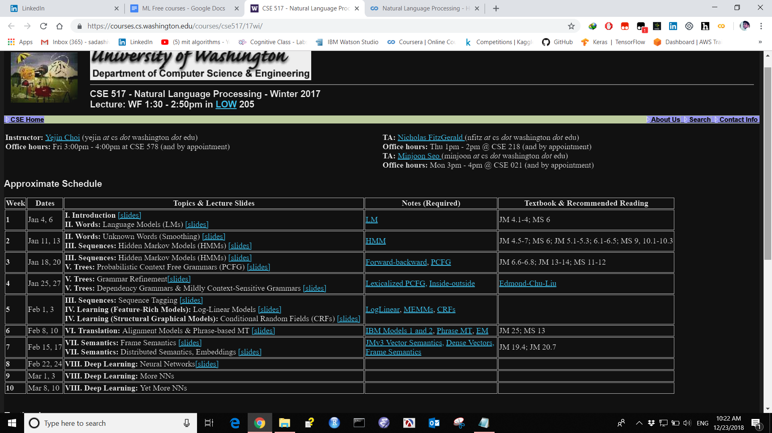

**11 Useful Jupyter Notebook for coding**

<http://nbviewer.jupyter.org/github/roamanalytics/roamresearch/blob/master/BlogPosts/Modern_TensorFlow/modern-tensorflow.ipynb>

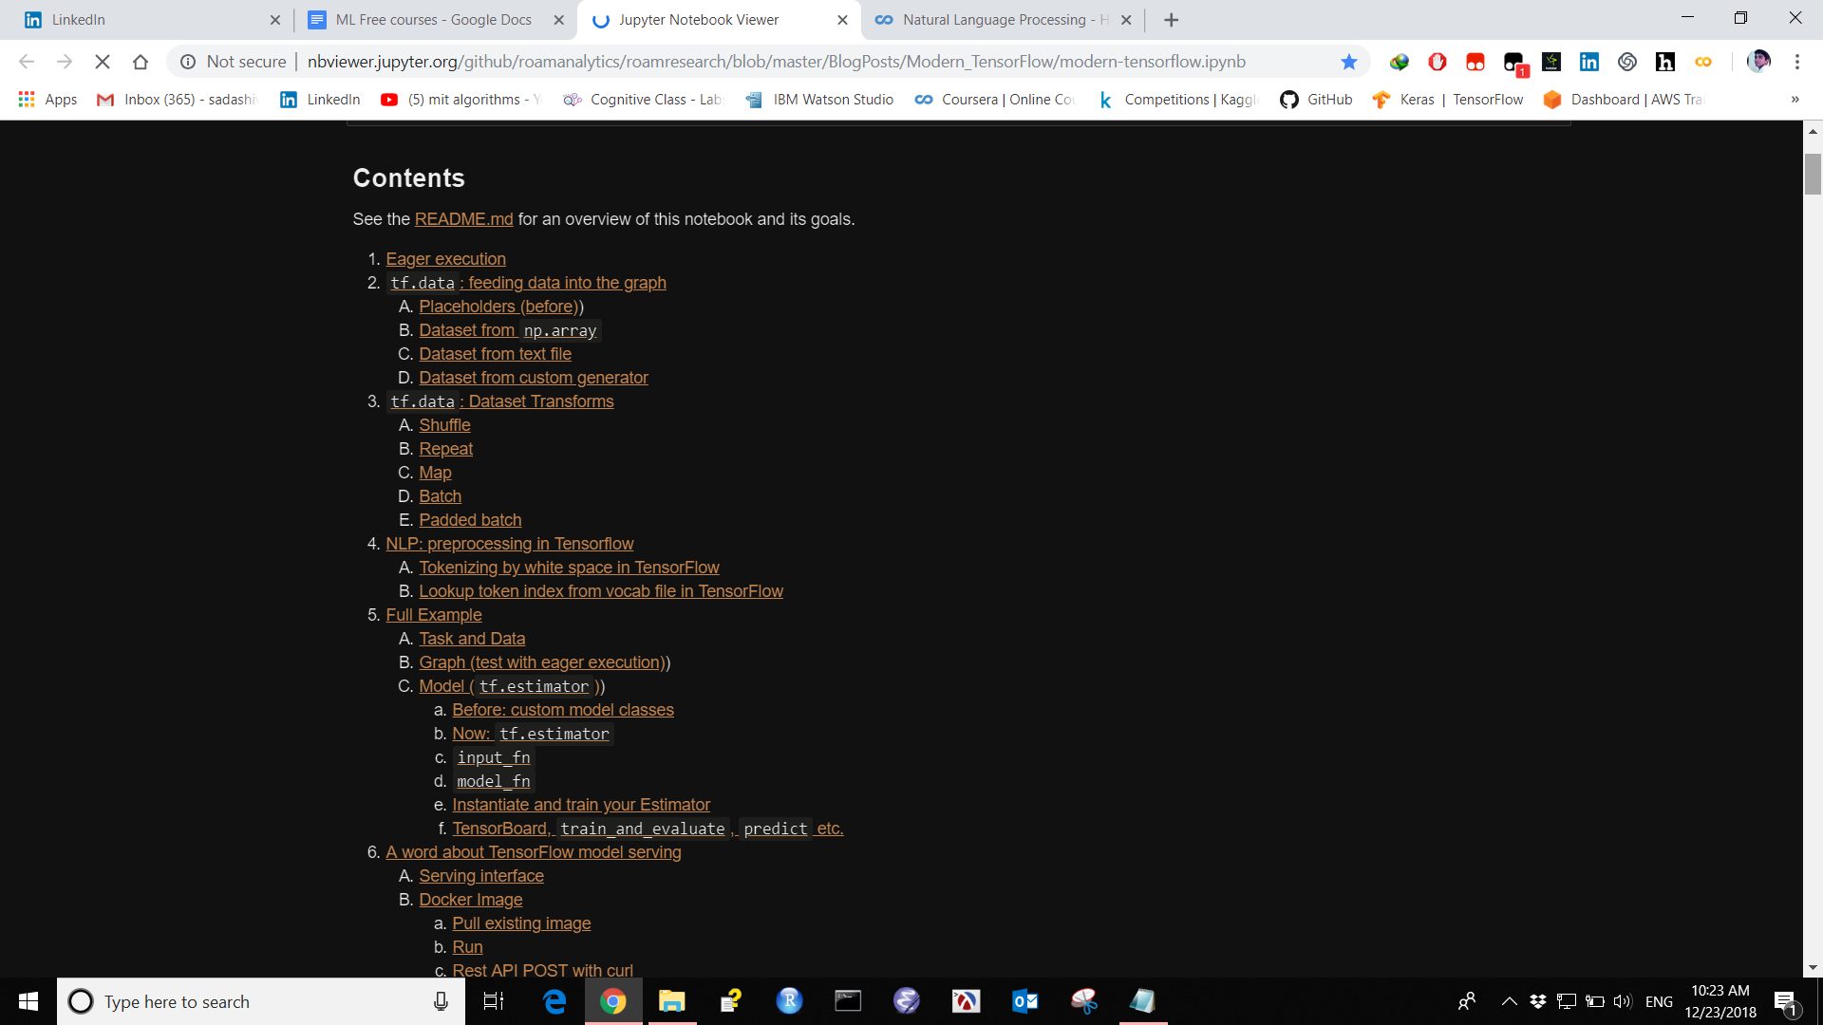

**12 AI Saturday learning plan ML DL AI**

<https://docs.google.com/document/d/1yLjTcuaQSE10uDUDKrvfQO2-FlAdWv8ZC5zH0SyBHY8/edit>

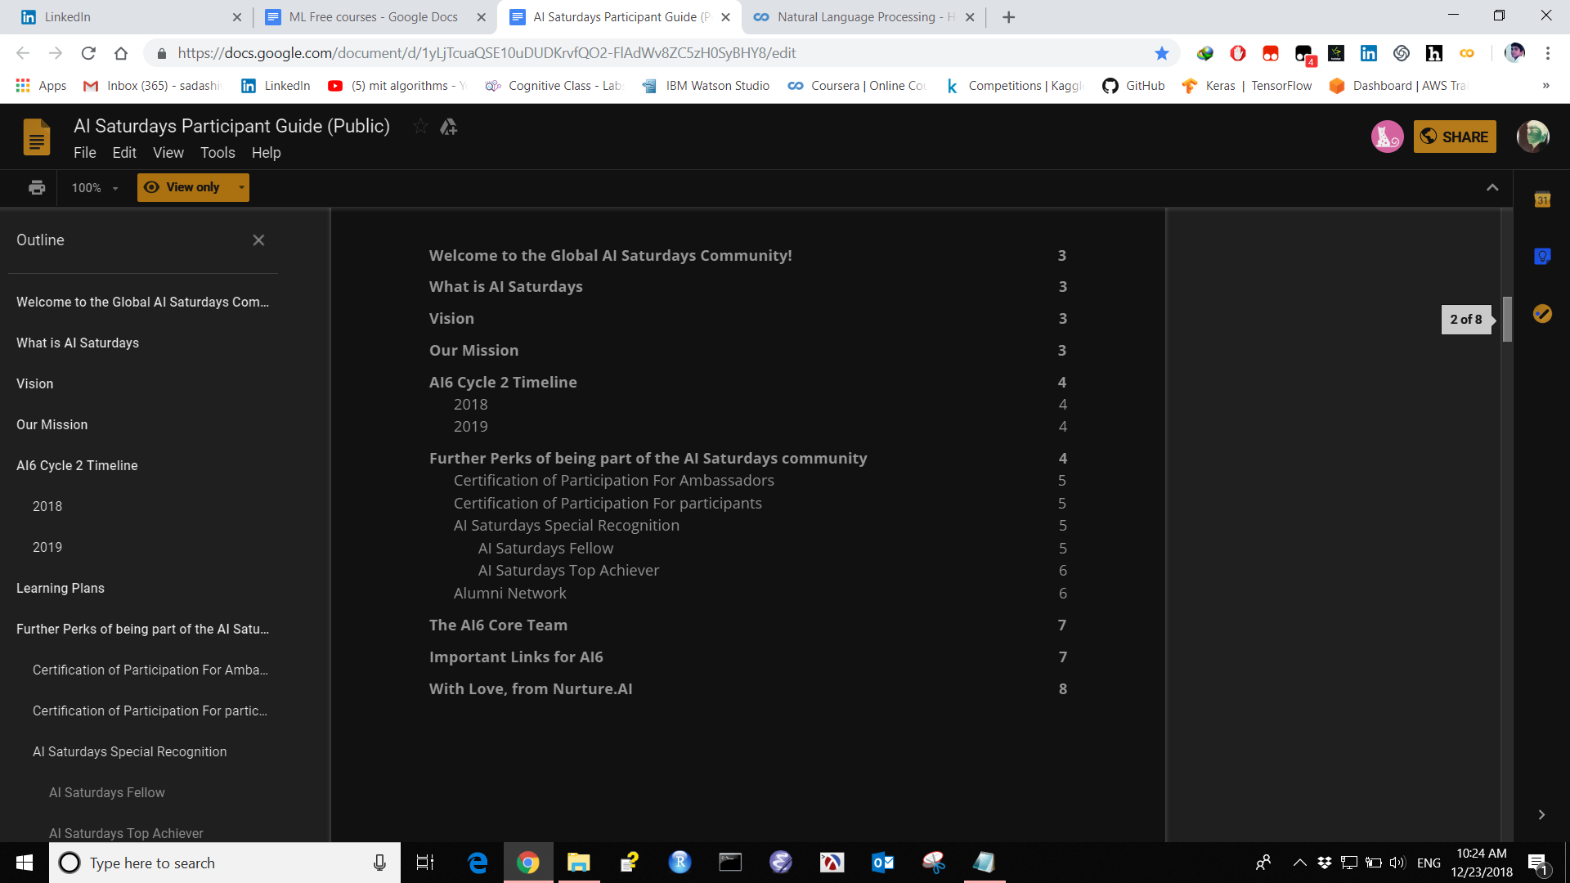

**13 Convolutional Neural Network for artistic style transfer**

<https://harishnarayanan.org/writing/artistic-style-transfer/>

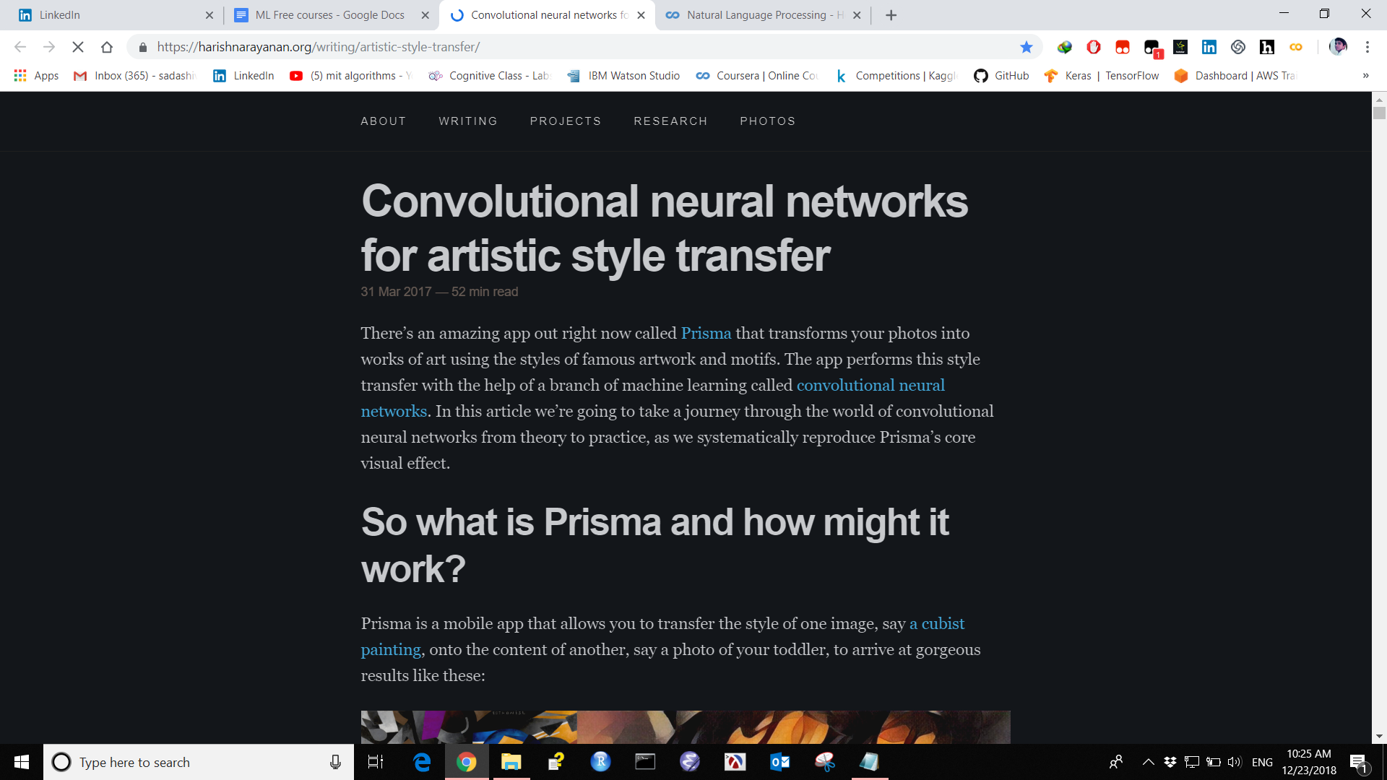

**14 Deep Learning course: lecture slides and lab notebooks**

<https://m2dsupsdlclass.github.io/lectures-labs/>

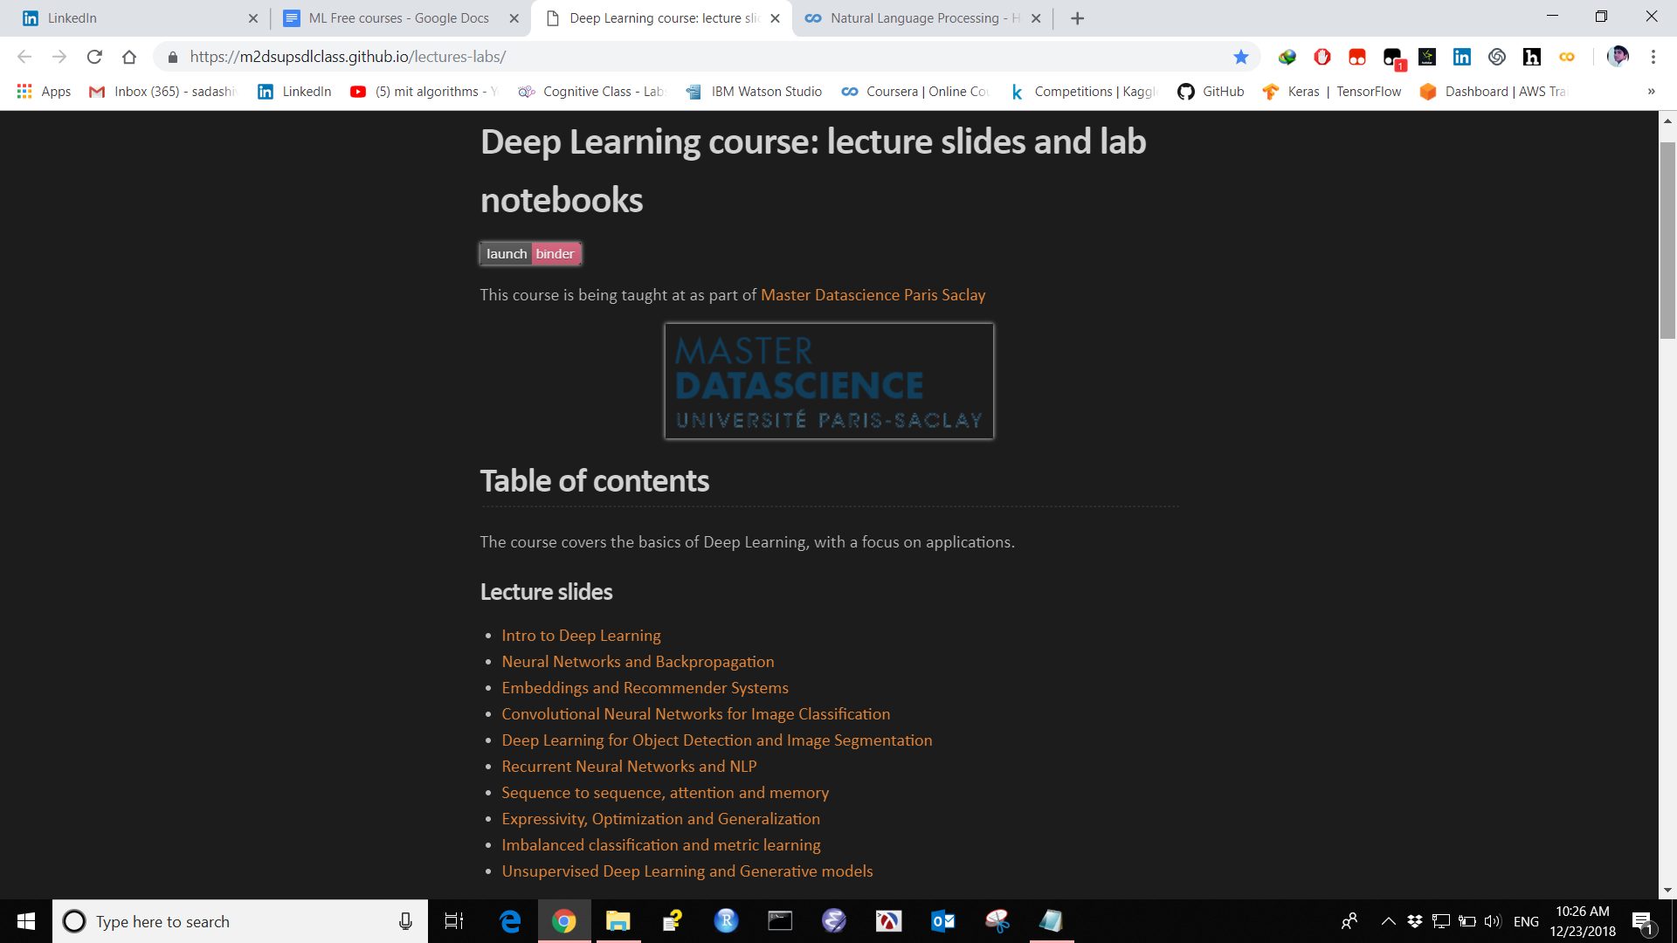

**15 Deep RL BOOTCAMP**

Contains Lectures slides books.

<https://sites.google.com/view/deep-rl-bootcamp/lectures>

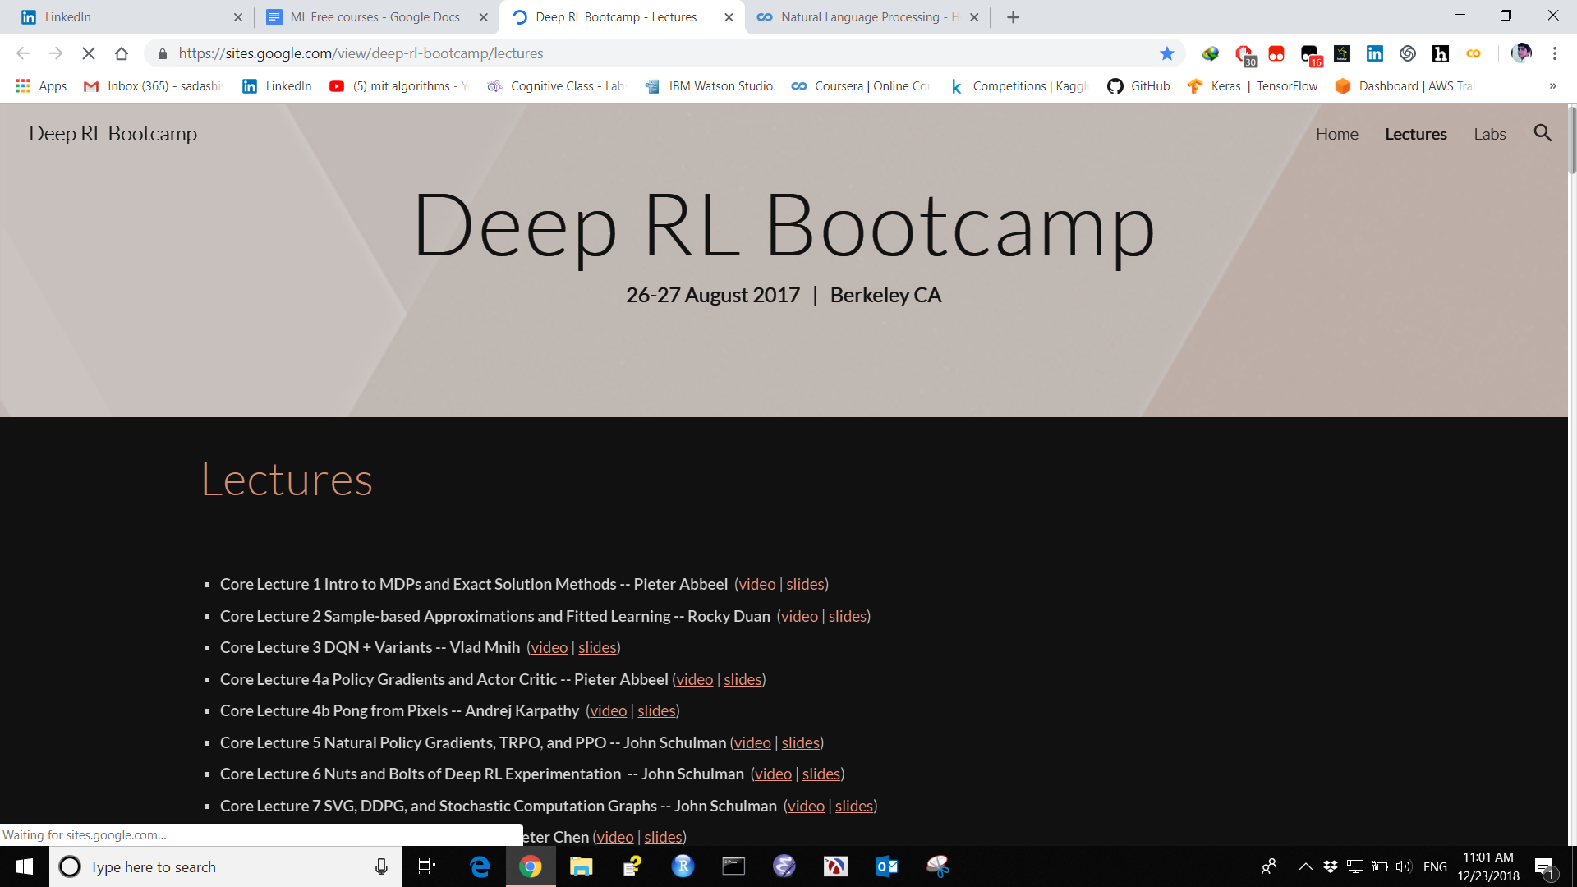

**16 monteral.ai**

Contain ML AI Lectures Slides Books

<https://montrealartificialintelligence.com/academy/>

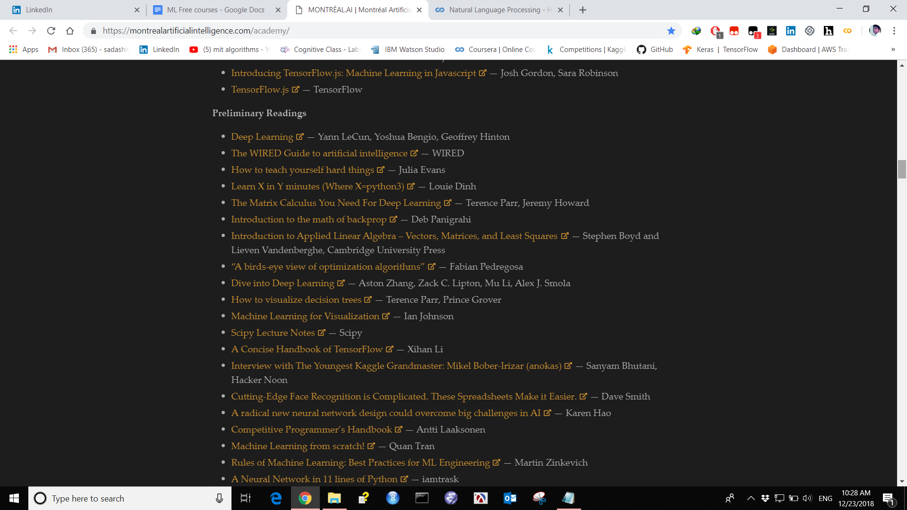

**17 From GAN to WGAN**

<https://lilianweng.github.io/lil-log/2017/08/20/from-GAN-to-WGAN.html#generative-adversarial-network-gan>

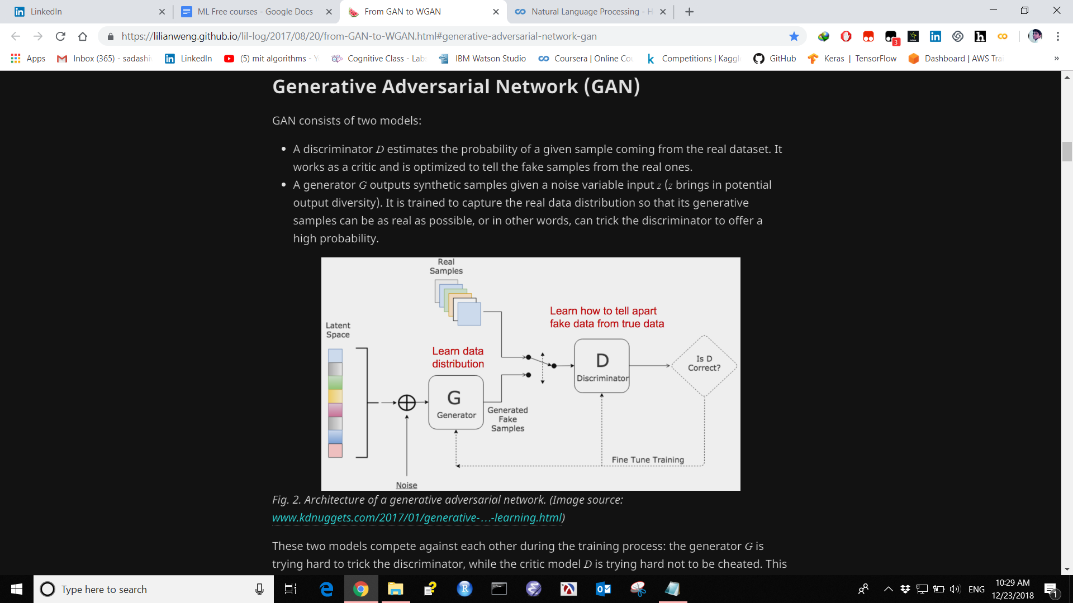

**18 Google cloud ML Courses Github repository**

Contain Google cloud repository code from Google cloud training course.

<https://github.com/GoogleCloudPlatform/training-data-analyst>

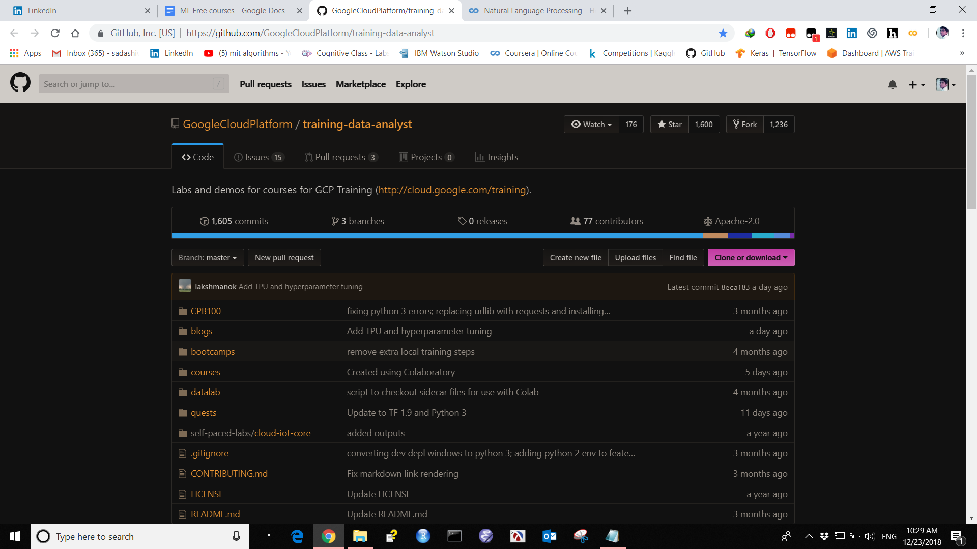

**19 Deep learning Machine learning Papers with code**

Contain Papers of ML DL with code.

<https://paperswithcode.com/>

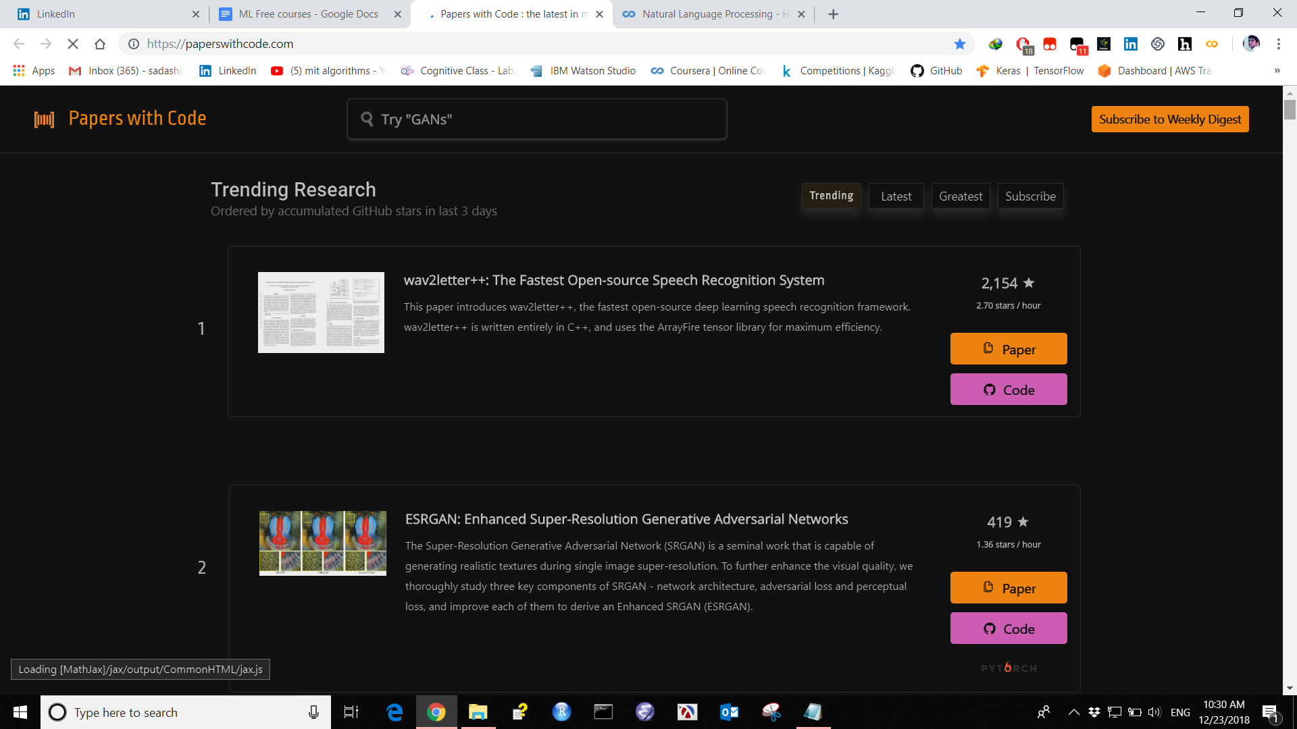

**20 Cognitive class By IBM for data science Machine learning**

Contain spark Scala Data science track path ML track path Hands on Chatbot.

<https://cognitiveclass.ai/>

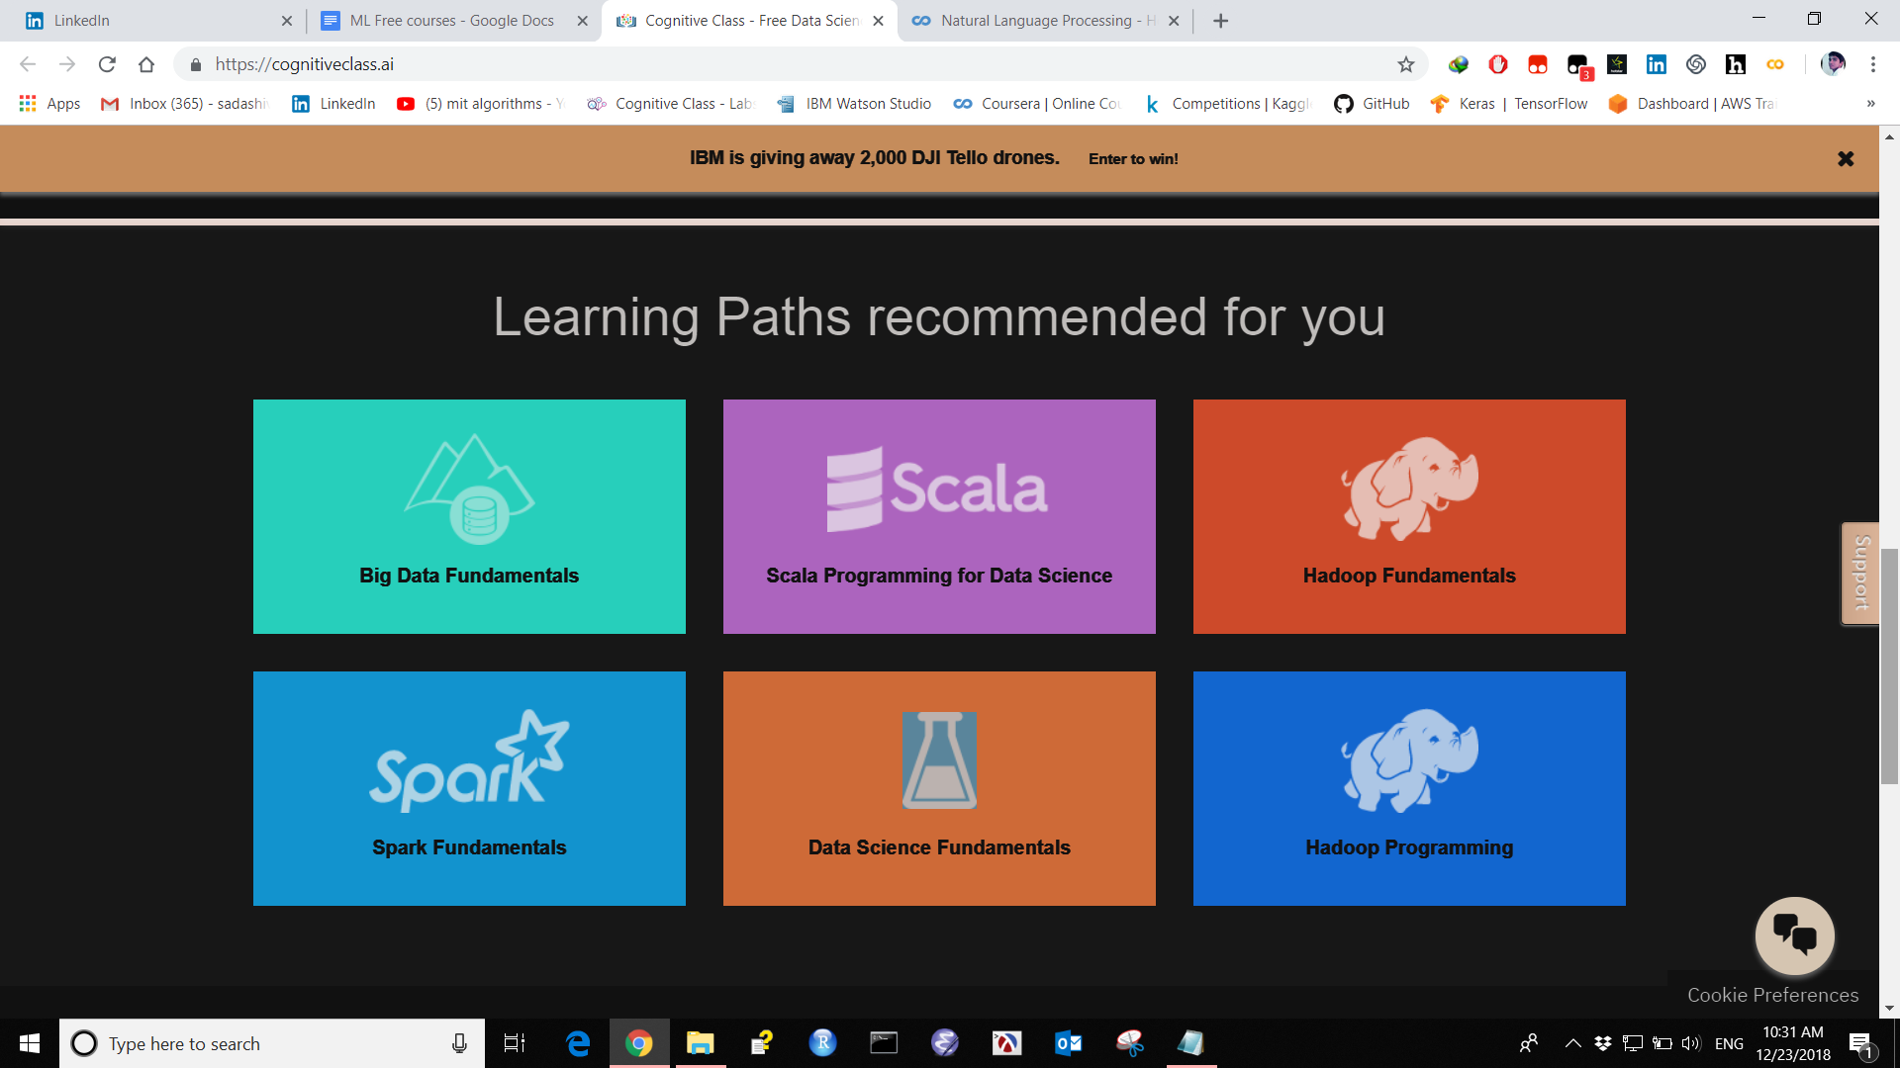

**21 AWS Training BY Amazon to learn ML AI Data Science with certificate**

AWS training with certificates for free make your career in AWS Cloud course contain ML DL AI DS.

<https://www.aws.training/Dashboard>

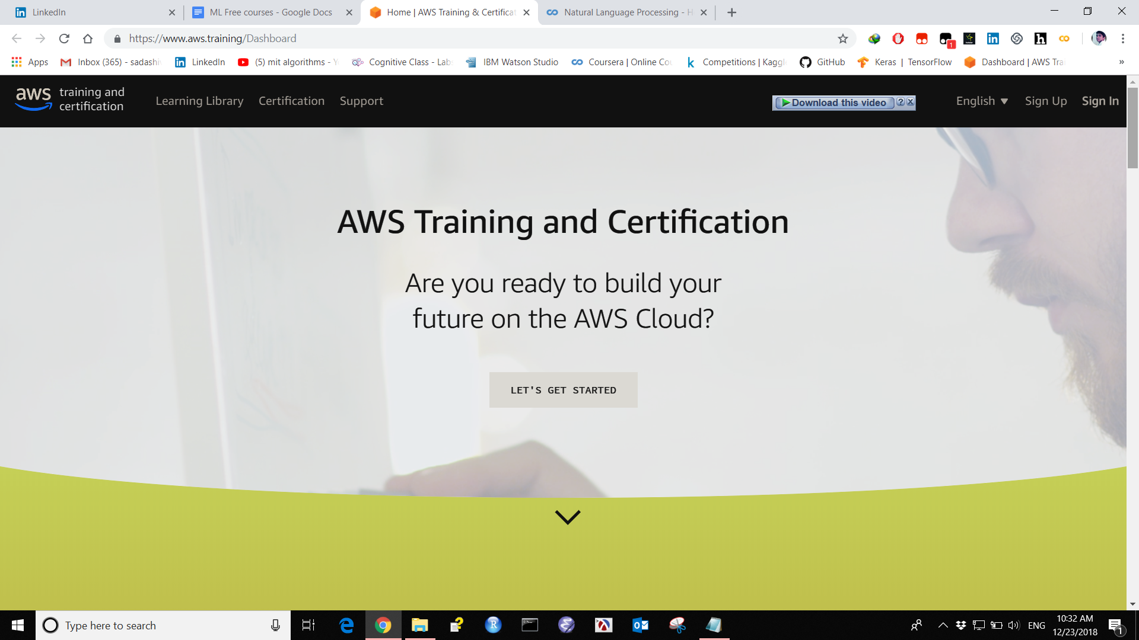

**22 Google colab to learn with practice on Cloud**

Contain Google colab on cloud

<https://colab.research.google.com/notebooks/welcome.ipynb#scrollTo=-Rh3-Vt9Nev9>

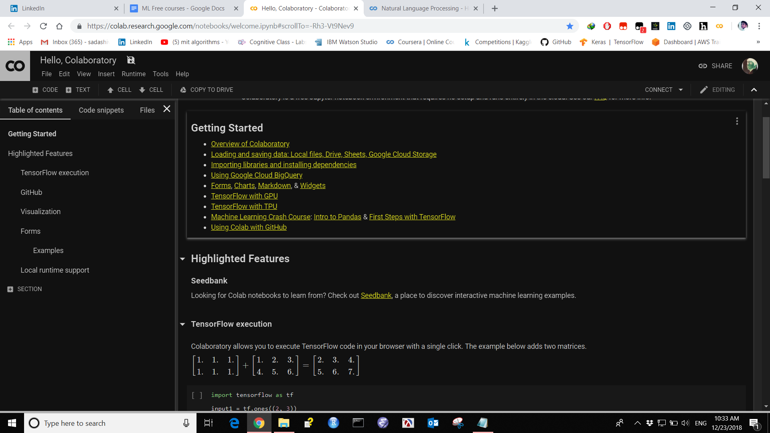

**23 NLP Notebook**

**A** Useful Book - Natural Language processing contains Code and Algorithm.

<https://docs.google.com/presentation/d/17NoJY2SnC2UMbVegaRCWA7Oca7UCZ3vHnMqBV4SUayc/edit#slide=id.p>

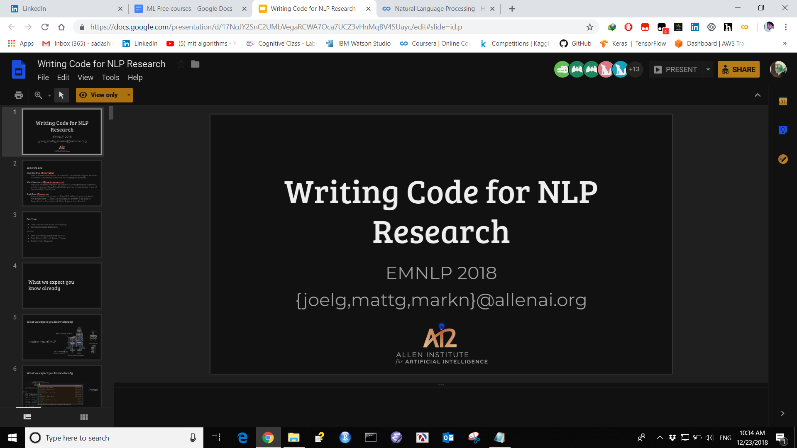

**24 A Gallery of Interesting Notebook**

Contains Interesting Code in python for ML DL.

<https://github.com/jupyter/jupyter/wiki/A-gallery-of-interesting-Jupyter-Notebooks#c>

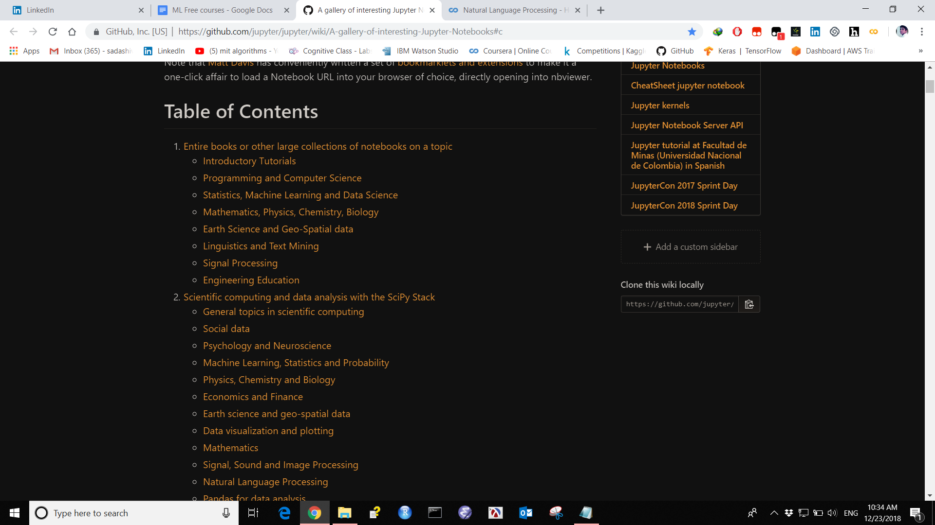

**25. Some Useful Cheat Sheets**

Pics of useful Cheat sheets containing Pandas numpy ML AI DS cheat sheets.

<https://github.com/SadaShivPal/some-useful-cheat-sheets-in-ML-AI-Data-science>

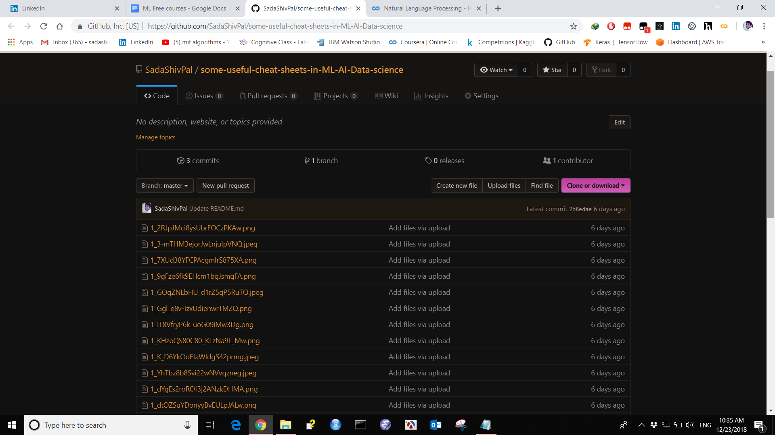jh

**Deep Learning Lectures UC Berkeley**

**Register for Fall2018**

<https://inst.eecs.berkeley.edu/~cs188/fa18/>

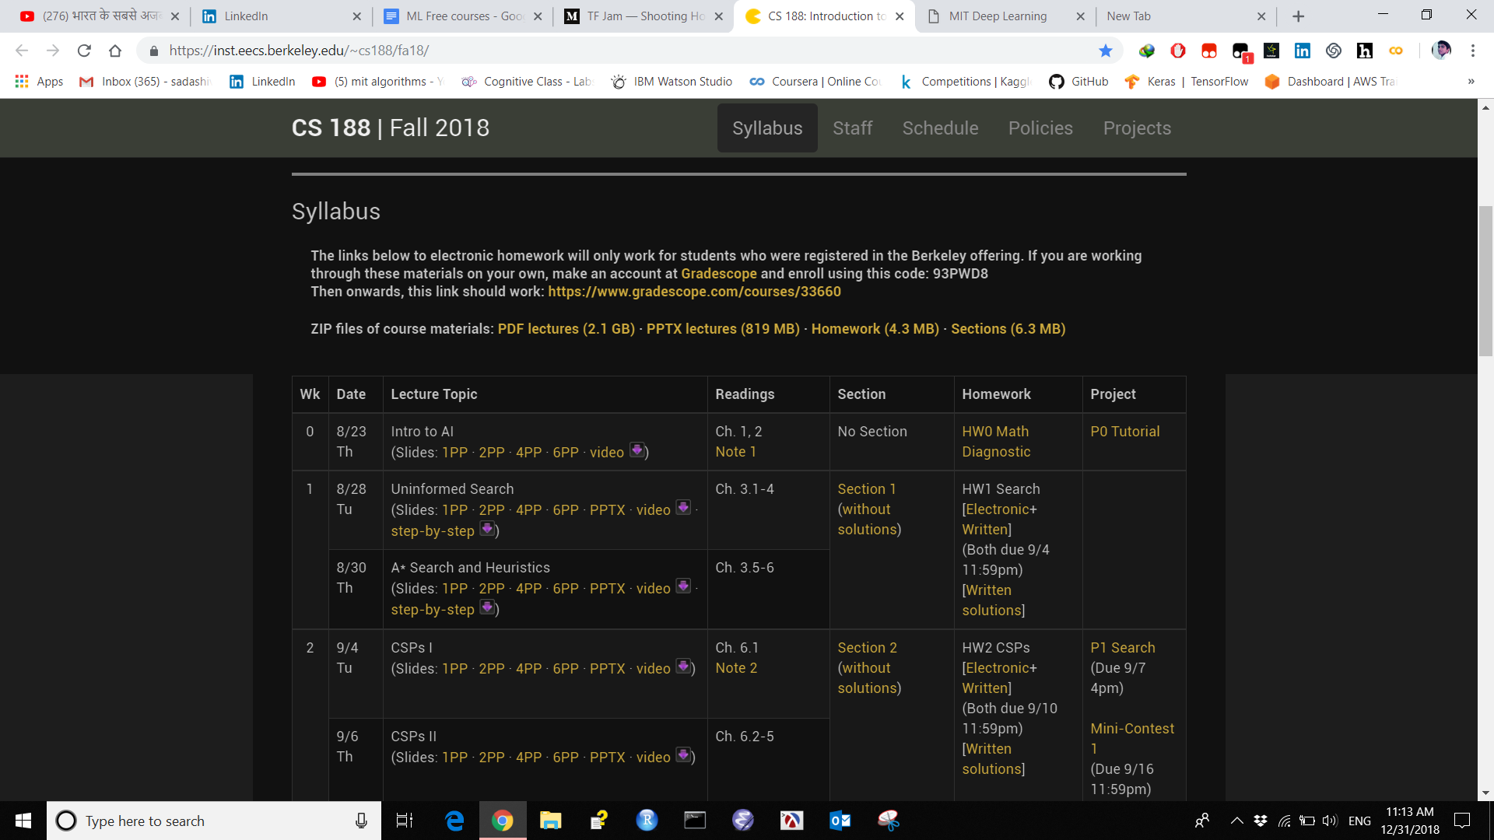

# [MIT Deep Learning](https://deeplearning.mit.edu/)

<https://deeplearning.mit.edu/>

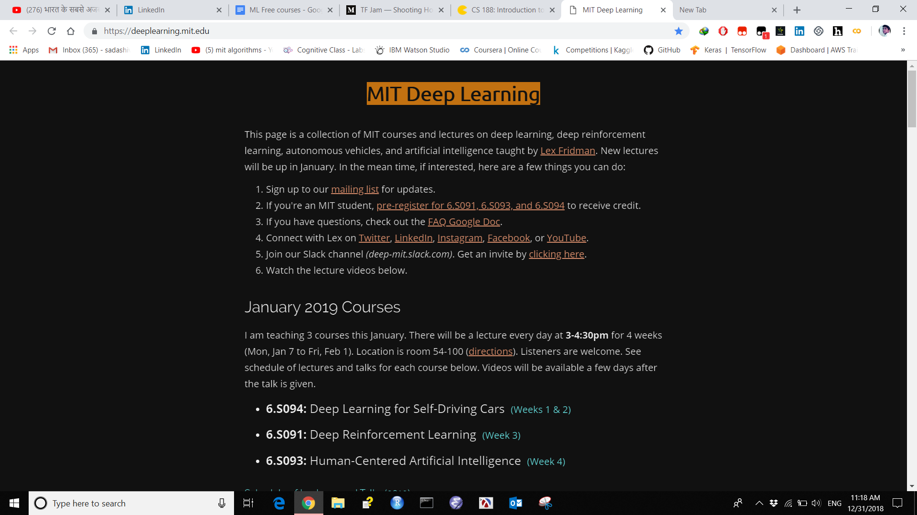

**Open Source Society University**

<https://github.com/ossu/data-science>

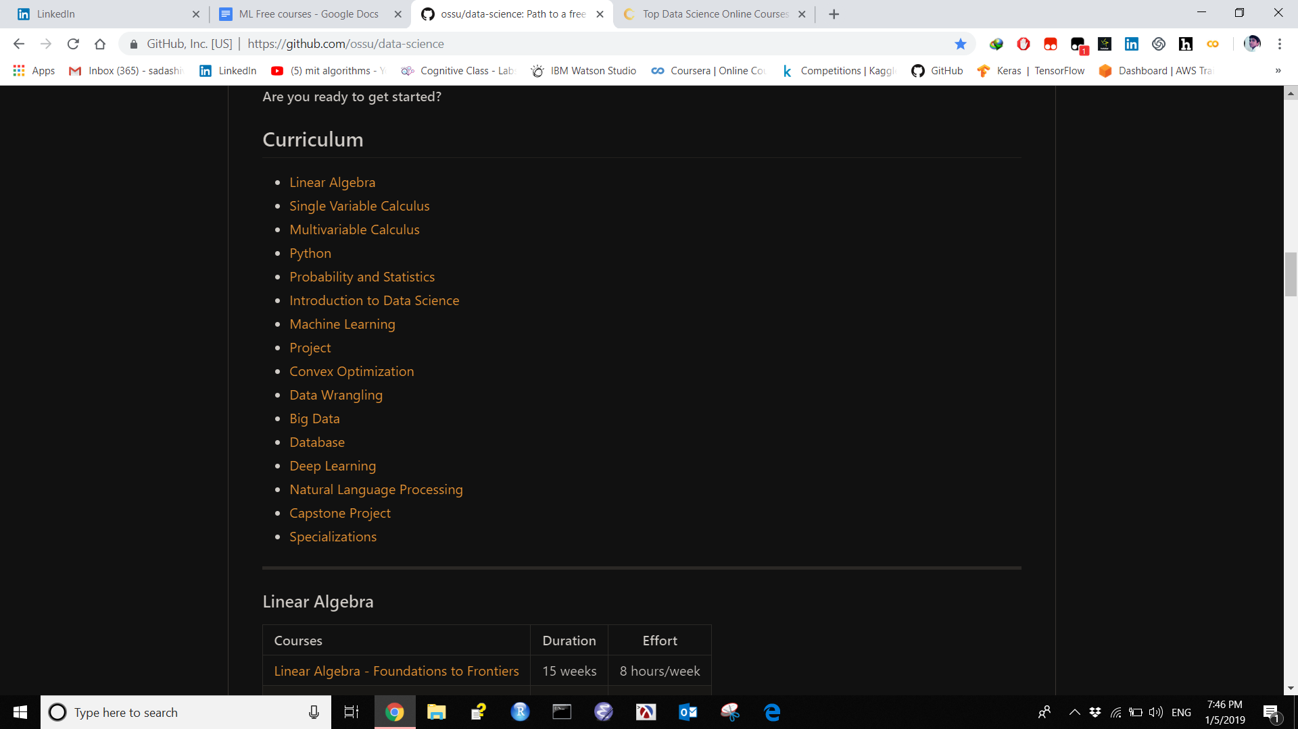

# **Top Data Science Online Courses in 2018**

<https://www.learndatasci.com/best-data-science-online-courses/>

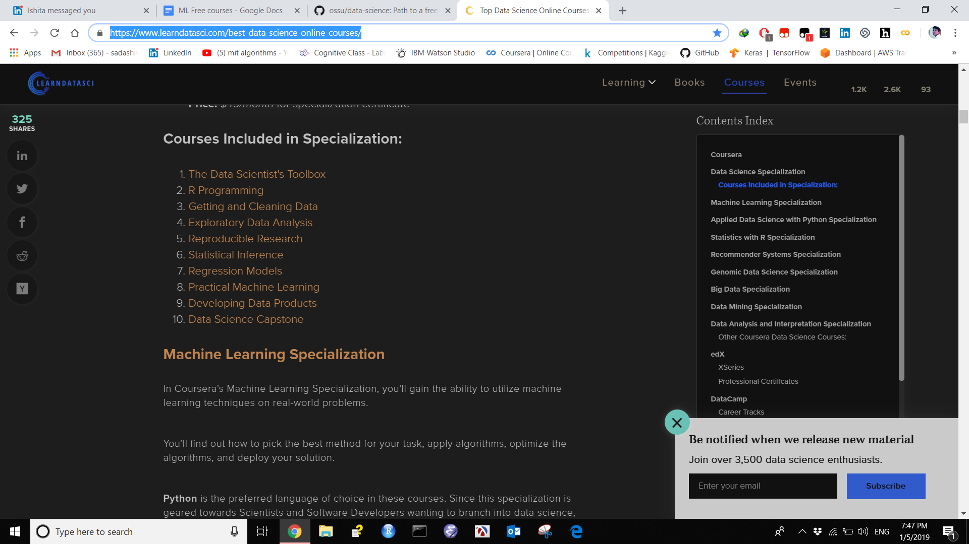

**The best curated list of Data Science materials on the web!**

<http://www.claoudml.co/>

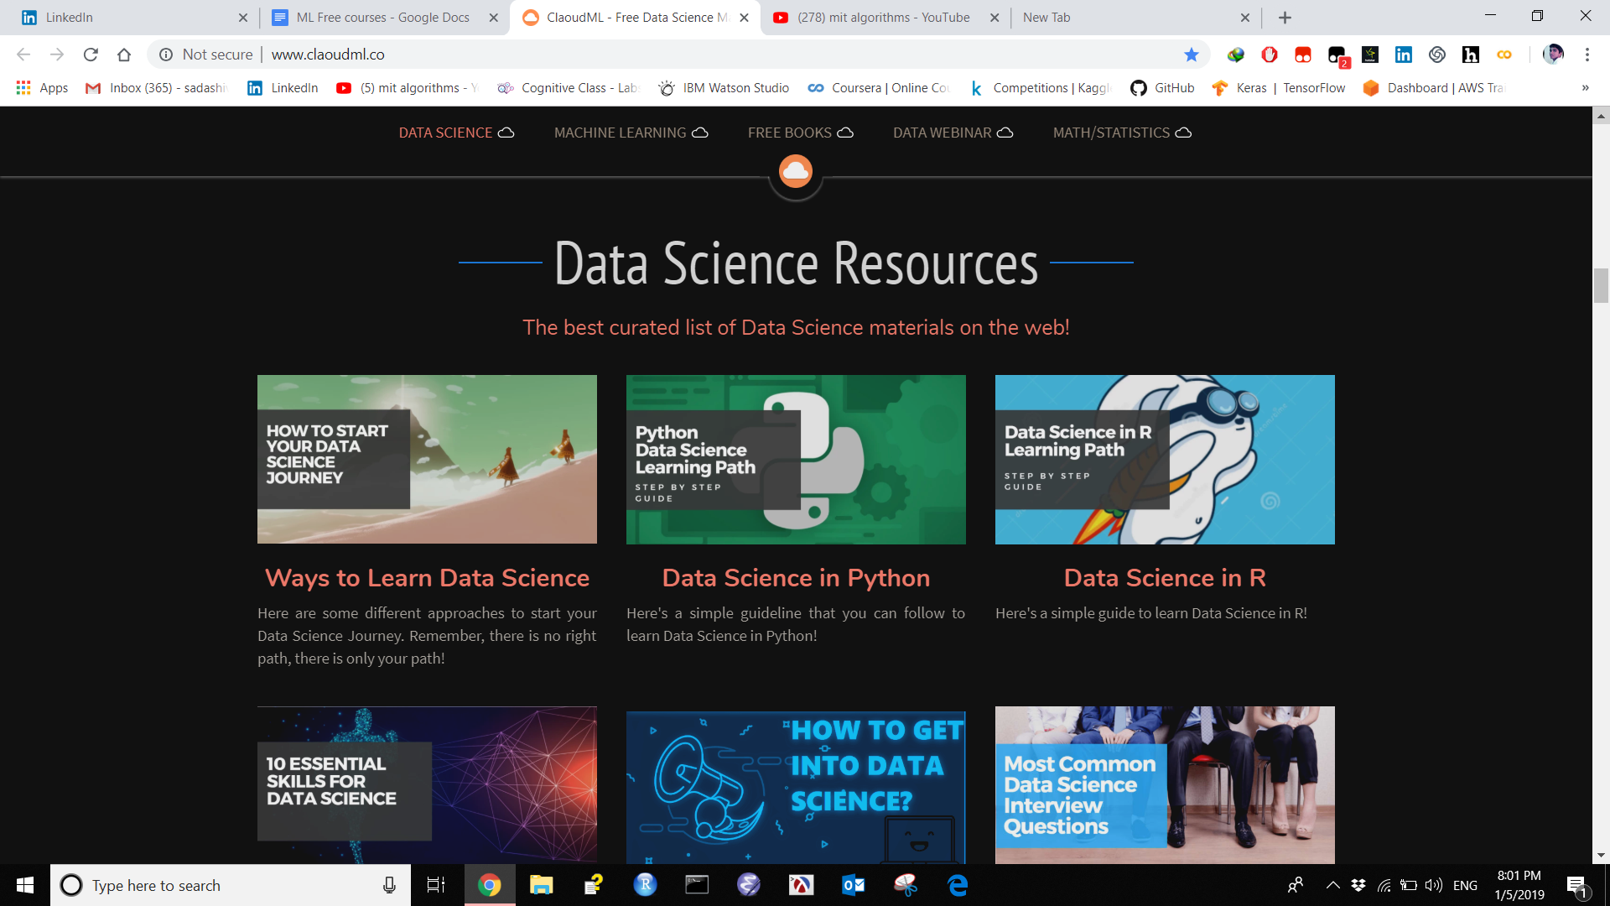

# 

# 

# [MIT Deep Learning](https://deeplearning.mit.edu/)

<https://deeplearning.mit.edu/>

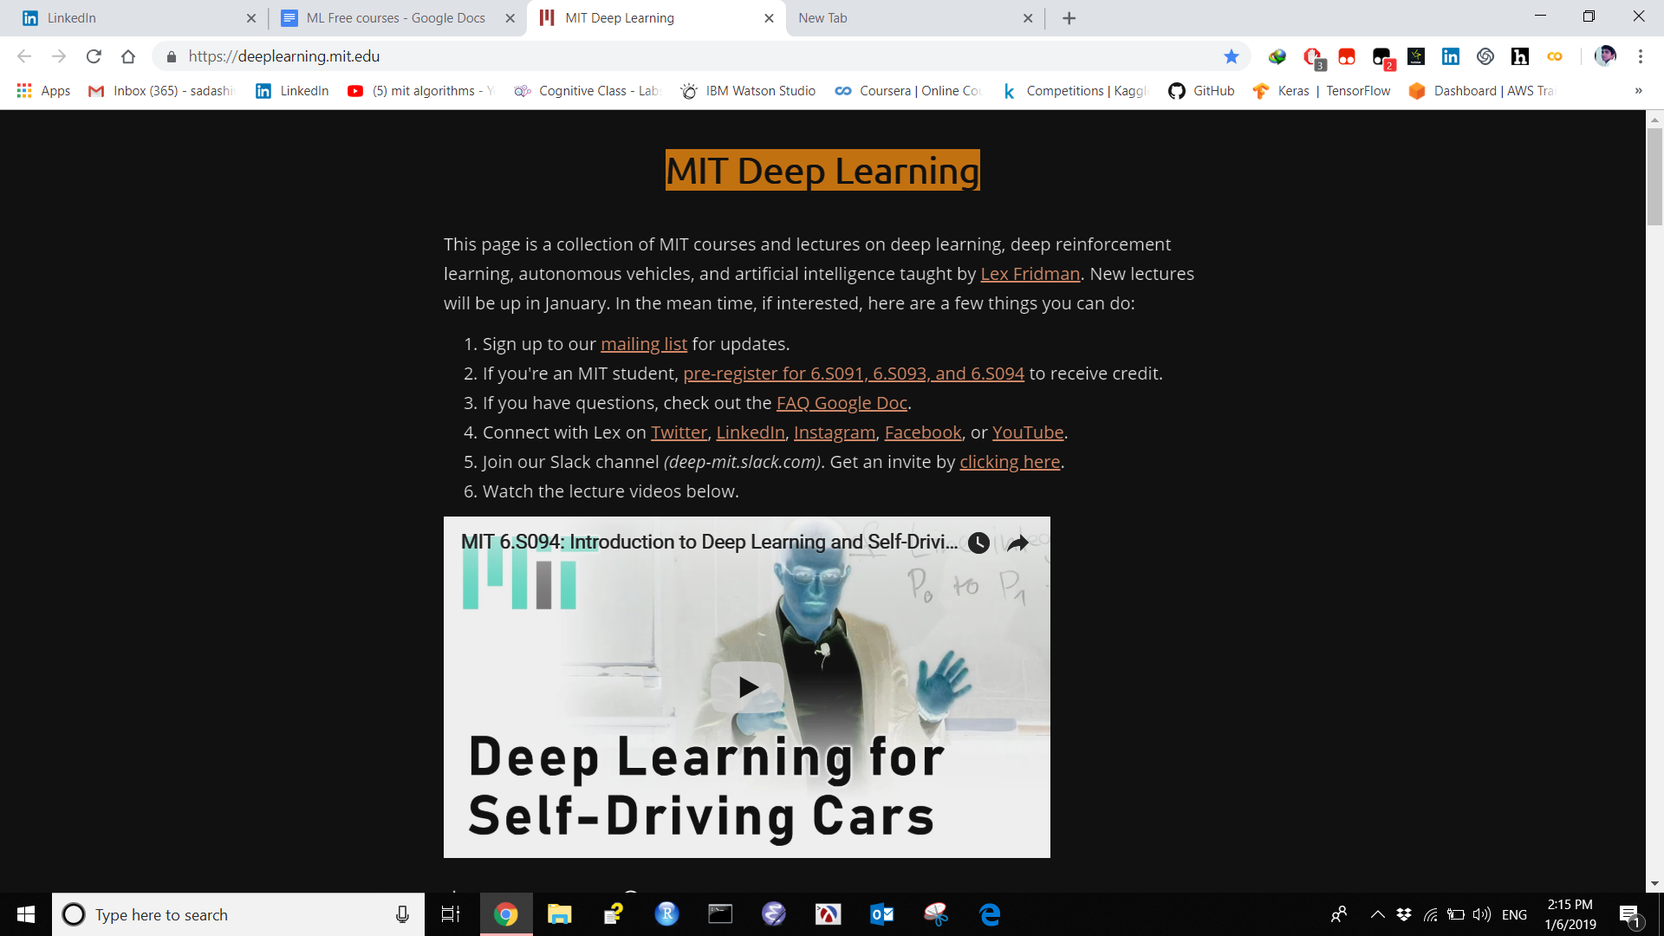

|  |  |  |  |  |
| --- | --- | --- | --- | --- |
|  |  |  |  |  |
| **Deep Learning Summer School** | | | | |

<http://videolectures.net/DLRLsummerschool2018_toronto/>

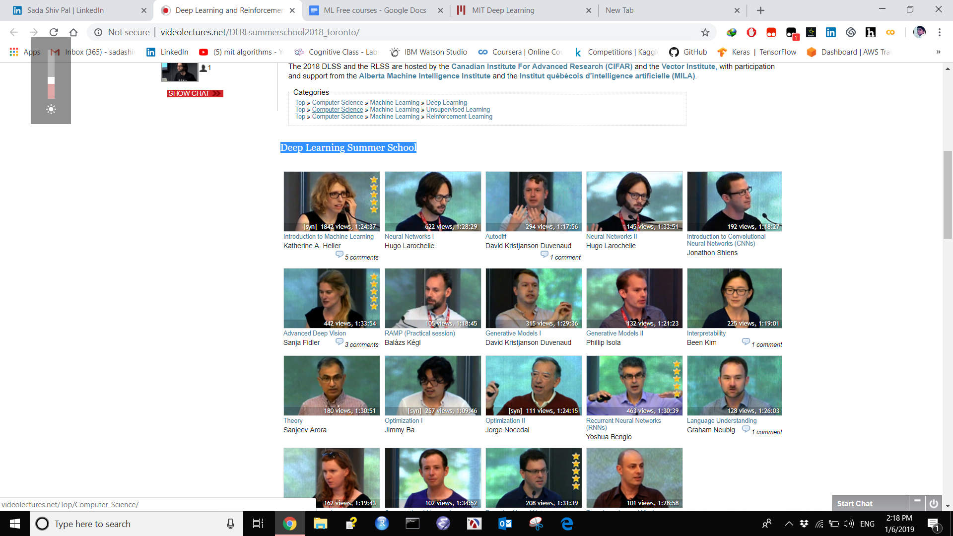

# 

# 

# **Data Science Flashcards**

<https://www.brainscape.com/subjects/data-science>

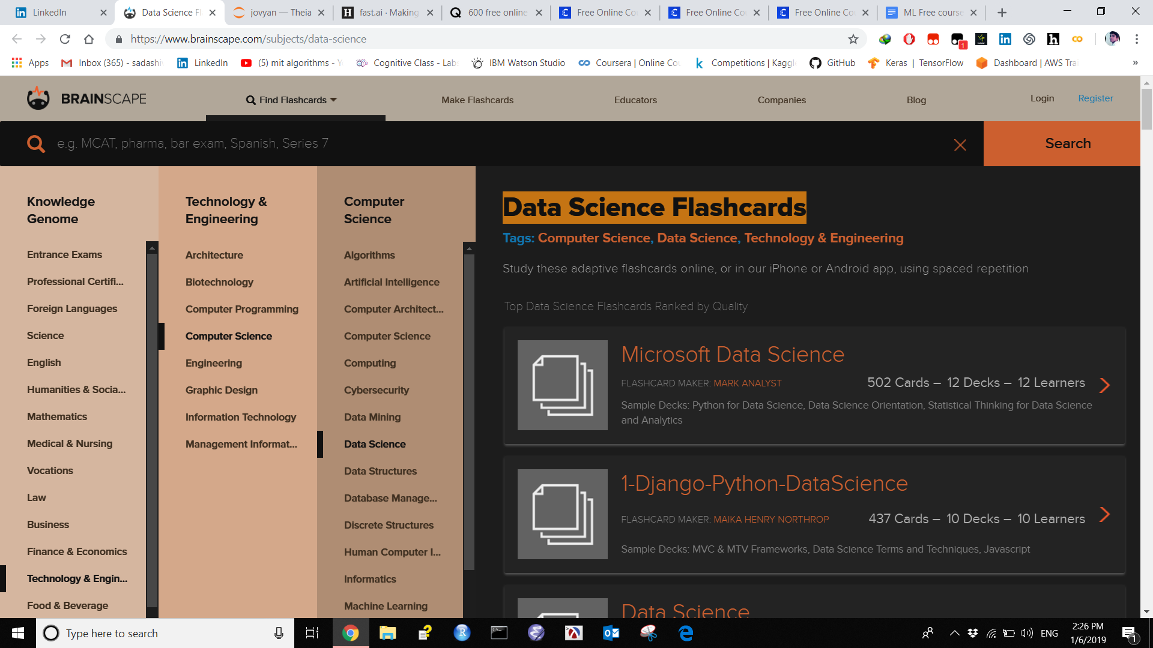

**Fast.AI**

<https://www.fast.ai/>

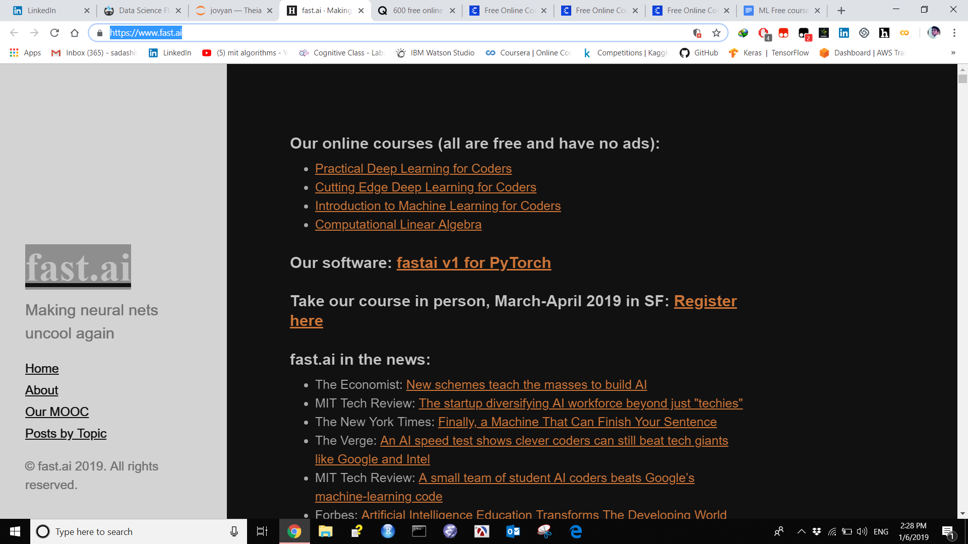

[Fast.ai version-3](https://www.fast.ai/2019/01/24/course-v3/)

# **190 universities just launched 600 free online courses. Here’s the full list**

<https://qz.com/1437623/600-free-online-courses-you-can-take-from-universities-worldwide/>

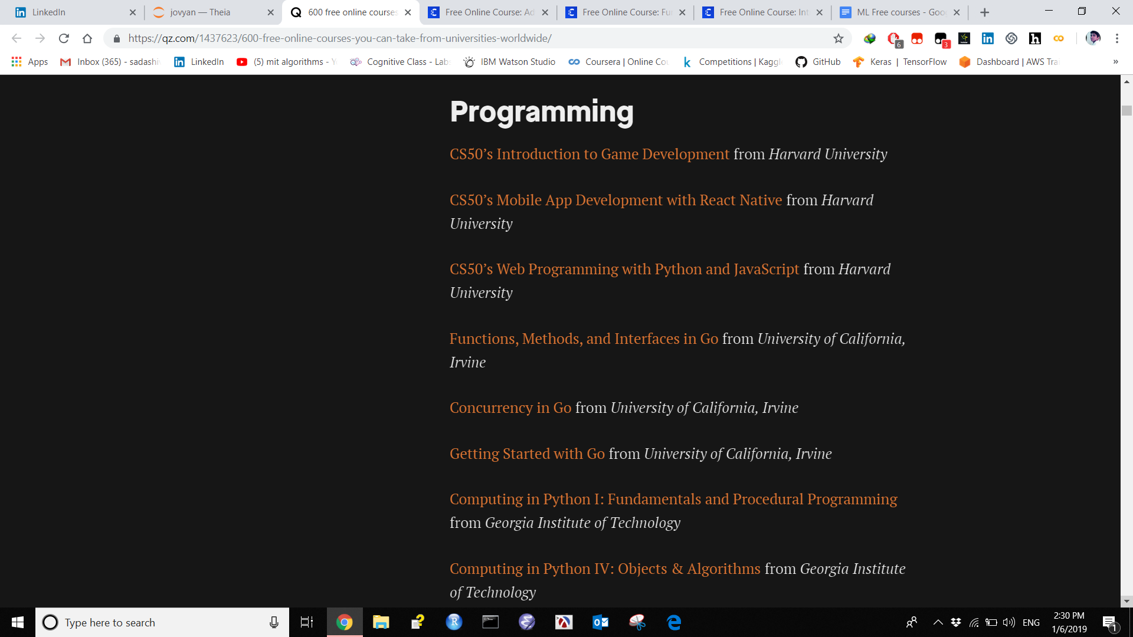

**Advanced Algorithmics and Graph Theory with Python**

<https://www.class-central.com/course/edx-advanced-algorithmics-and-graph-theory-with-python-12017>

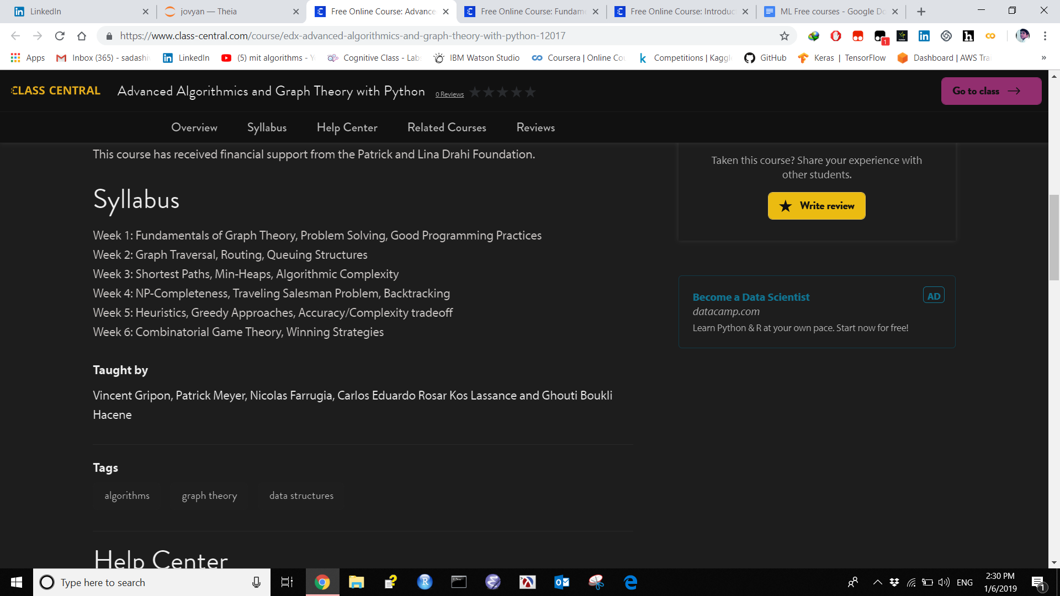

**Fundamentals of Machine Learning**

<https://www.class-central.com/course/complexity-explorer-fundamentals-of-machine-learning-11493>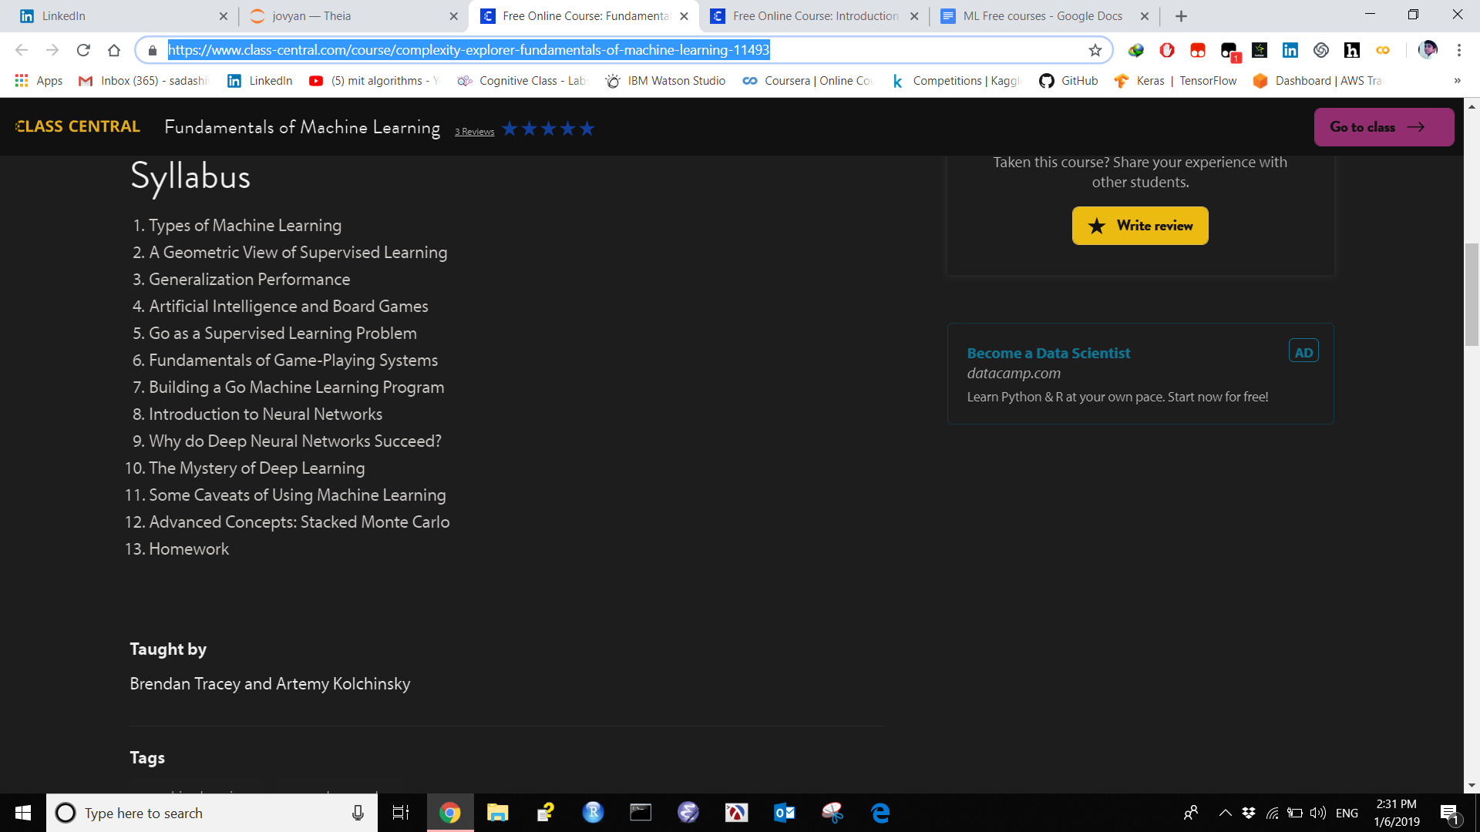

**Introduction to Machine Learning**

<https://www.class-central.com/course/coursera-introduction-to-machine-learning-12086>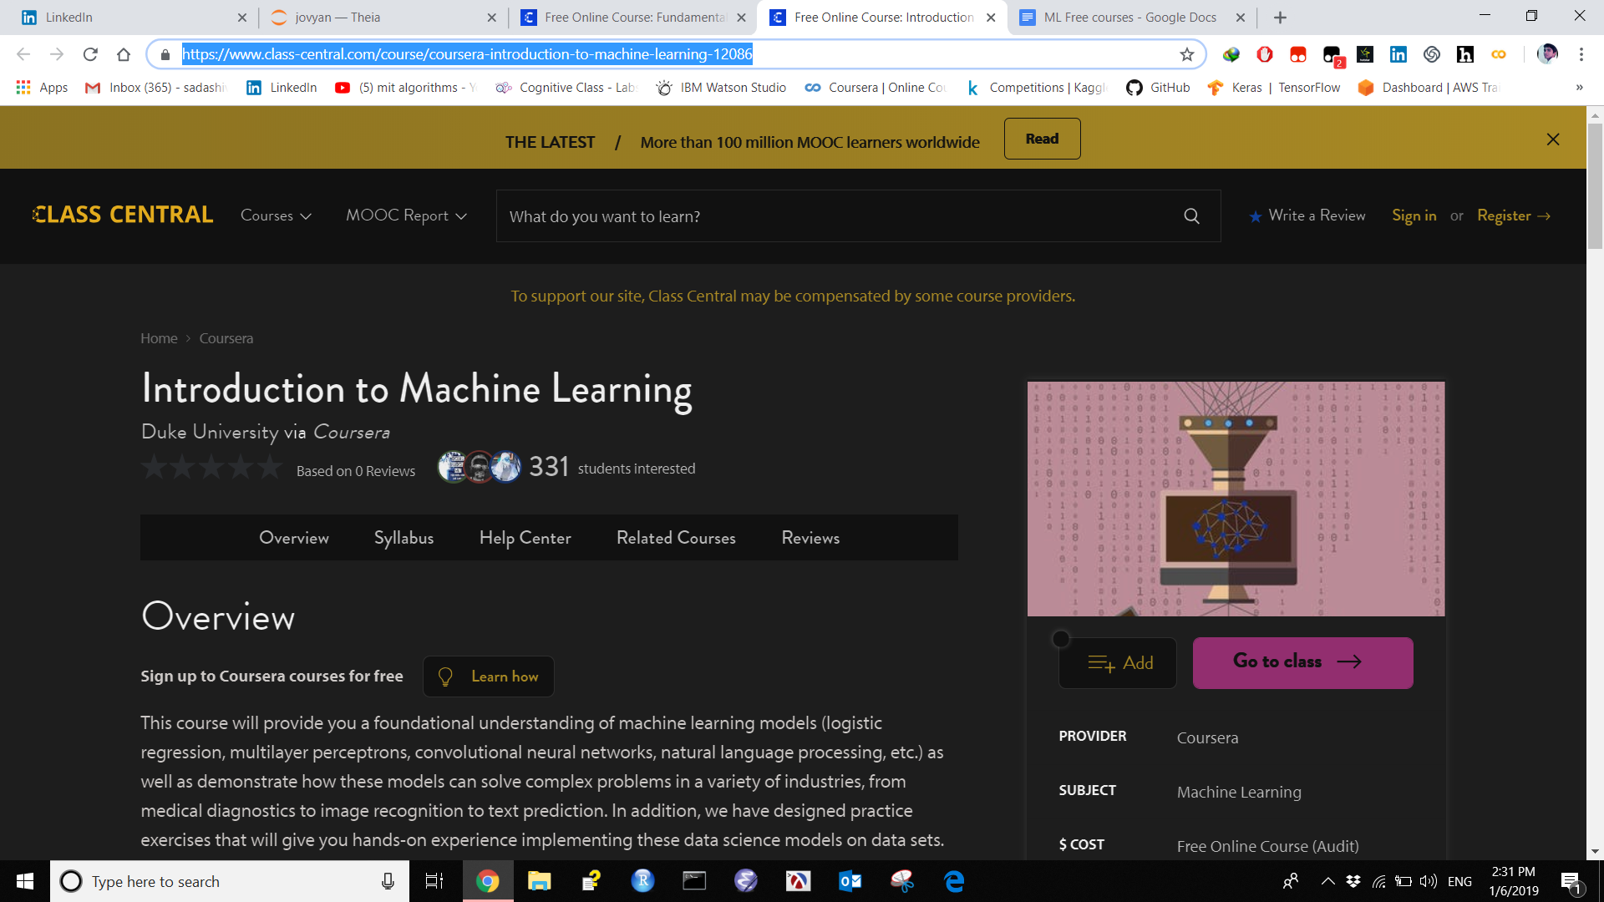

## **Topic Modeling**

Vowpal wabbit

<http://hunch.net/~vw/>

State of Art Modeling

<http://bigartm.org/>

Gensim

<https://radimrehurek.com/gensim/tutorial.html>

Textvisualization

<http://textvis.lnu.se/>